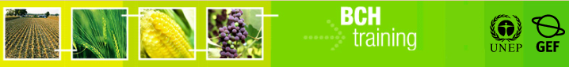

A User's Guide to the Central Portal of the Biosafety Clearing-House

“Surfing the BCH Central Portal”

March 2012

Version: 5.0

**Reproduction**  
  
The content of this publication may be reproduced in whole or in part and in any form for educational or non-profit purposes without special permission from the copyright holder, provided acknowledgment of the source is made. UNEP would appreciate receiving a copy of any publication that uses this publication as a source. No use of this publication may be made for resale or any other commercial purpose whatsoever without prior permission in writing from UNEP. The use of information from this website concerning proprietary products for publicity or advertising is not permitted.

**Disclaimers**The content and views expressed in this publication do not necessarily reflect the views or policies of the contributory organizations or the United Nations Environment Program (UNEP) and neither do they imply any endorsement. The designations employed and the presentation of material in this publication do not imply the expression of any opinion whatsoever on the part of UNEP concerning the legal status of any country, territory or city or its authorities, or concerning the delimitation of its frontiers and boundaries. Mention of a commercial company or product in this publication does not imply the endorsement of UNEP.

Manual Outline

1 Introduction to the manual 5

BCH Central Portal 6

2 Home Page 6

2.1 The Management Centre 8

2.2 Latest News 8

2.3 Latest Additions 9

2.4 Latest Updates 11

3 The Navigation Bar 12

3.1 The “Country Profiles” 14

3.2 The BCH 15

3.2.1 Biosafety Clearing-House 16

3.2.1.1 Modalities of Operation 16

3.2.1.2 Multi-year Program of Work 17

3.2.1.3 Decisions on the BCH 18

3.2.1.4 Reports and Reviews 19

3.2.1.5 Development of the BCH 20

3.2.2 The BCH Collaborative Portal 21

3.2.2.1 About this Portal 21

3.2.2.2 The BCH Informal Advisory Committee (BCH-IAC) 22

3.2.2.3 Forum of National Focal Point (BCH on BCH) 24

3.2.2.4 UNEP-GEF BCH Projects 24

3.2.3 Highlights 25

3.2.3.1 BCH News 25

3.2.3.2 Latest Additions 26

3.2.3.3 Notifications 27

3.2.3.4 Meetings and Documents 27

3.2.4 Policies 28

3.2.4.1 Linking External Websites Policy 28

3.2.4.2 Privacy Policy 29

3.2.4.3 Disclaimer 30

3.2.4.4 Copyright 31

3.3 The Protocol 32

3.3.1 The Cartagena Protocol 33

3.3.1.1 What’s new 33

3.3.1.2 About the Protocol 34

3.3.1.3 Text of the Protocol 35

3.3.1.4 Strategic Plan 35

3.3.2 Key Protocol Issues 36

3.3.3 Parties 37

3.3.3.1 List of Parties 37

3.3.3.2 Becoming a Party 38

3.3.3.3 National Contacts 39

3.3.3.4 National Reports 40

3.3.3.5 Status of Contributions 41

3.3.4 COP-MOP (Governing Body) 42

3.3.4.1 COP-MOP Bureau 42

3.3.4.2 COP-MOP Meetings 43

3.3.4.3 COP-MOP Decisions 44

3.3.5 Activities and Documentation 46

3.3.5.1 Meetings and Documents 46

3.3.5.2 Notifications 46

3.3.5.3 Statements and Press Releases 47

3.3.5.4 Reports of the Executive Secretary 48

3.3.6 Resources 49

3.3.7 Publications 50

3.3.8 Nagoya - Kuala Lumpur Supplementary Protocol on Liability and Redress 52

3.4 Finding Information 53

3.5 Registering Information 55

3.6 Resources 56

3.6.1 Resources 57

3.6.1.1 Common Formats 57

3.6.1.2 Solutions for National Participation 59

3.6.1.3 Glossary 60

3.6.1.4 Thesaurus 60

3.6.1.5 Site Map 60

3.6.1.6 Offline copy of the BCH 61

3.6.1.7 LMO quick-links 62

3.6.1.8 Online Forums and Portals 63

3.6.1.9 Interoperability Services 64

3.6.1.10 Mailing Lists 65

3.6.2 Training Site of the BCH 67

3.7 Help 68

3.7.1 Help 69

3.7.2 BCH Tutorials 70

3.7.3 Frequently Asked Questions 71

Introduction to the manual

What the user will learn in this manual:

1. To navigate the BCH Central Portal.
2. To understand the main functionalities of the Central Portal.
3. To know what information the user can find in the Central Portal.
4. To search the databases available on the Central Portal.

**Context**:

The UNEP-GEF Project for Capacity Building for Effective Participation in the Biosafety Clearing-House (BCH-I), in collaboration with the Secretariat of the Convention on Biological Diversity (SCBD), prepared a modular training package aimed at providing a practical “how-to” guide for countries to assist them in learning, understanding, using, and setting up national access to the BCH. The training package was later updated within the UNEP-GEF Project for Continued Enhancement of Capacity Building for Effective Participation in the BCH (BCH-II). It was designed to be flexible and is tailored to meet the diverse needs of different countries, allowing them to select those tools that are most useful to their situation, needs and priorities. The training package is divided into several manuals, each addressing one element of the BCH.

**Audience**:

This manual is designed to provide guidance to users of the BCH Central Portal. It is developed for a non-technical audience with little or no knowledge of the Protocol and the BCH, but with a need to understand the main functionalities of the BCH Central Portal.

**Purpose**:

This manual describes the main functions and information that can be found on the BCH Central Portal. Users will learn how to navigate the BCH Central Portal, including:

1. The different categories of information found on the BCH Central Portal;
2. The structure of information available on the BCH Central Portal.

Note that while users are connected to the BCH Central Portal (<http://bch.cbd.int/>) they can read the sections of this manual and surf its various components

(<http://bch.cbd.int/help/topics/en/webframe.html?BCH_Help_Complete_Manuals.html> ).

**© UNEP 2004-2012 all rights reserved**

[FOR ONLINE HELP ONLY]

# BCH Central Portal

This help topic aims at providing help and guidance on the usage of the Biosafety Clearing-House Central Portal. Online help for each of the BCH Central Portal sections can be found in the following topics.

Home Page

**URL:** [**http://bch.cbd.int/**](http://bch.cbd.int/)

The Home page of the BCH Central Portal is a Welcomepage that provides a gateway to each element of the BCH and all data stored in the Central Portal as well as in the international, regional and national nodes linked to the BCH.

This Welcome to the BCH Central Portal page of the BCH Central Portal has a welcome area that briefly introduces the BCH, provides a quick link to the Management Centre and provides information about highlights, such as the latest news about the BCH and biosafety in general, the most recent additions to the databases, as well as the latest updates of the published records.

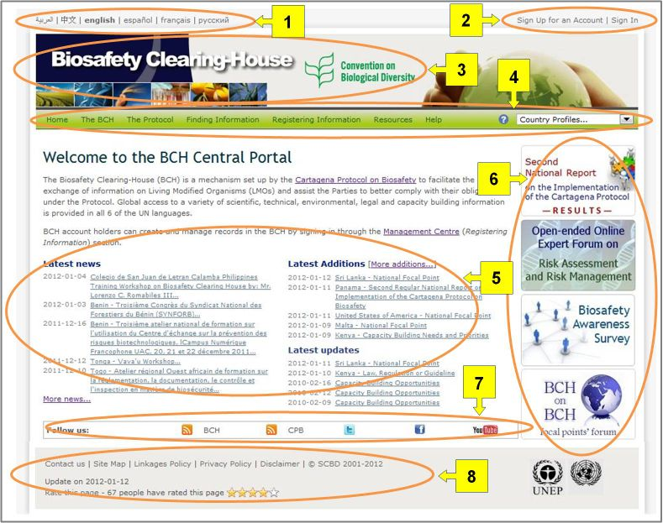

Figure

The components of the Welcome to the BCH Central Portal page are:

1. Links to the BCH in all six United Nations (UN) official **languages** are provided in the top left corner of the Home page.
2. A **Sign In** link for registered users (to access the management centre and other areas with limited access) and a link to **Sign up for an Account** (for new users to request a BCH account) are positioned in the top right corner.
3. Below these links you will find the title of the Biosafety Clearing-House and a link in the centre to the website of the **Convention on Biological Diversity**.
4. A navigation bar runs across the Home page below the title. It provides links to the main components of the Central Portal.
5. Below the navigation bar, there is a welcome area providing quick links to the **Cartagena Protocol on Biosafety** web-page and to the Management Center, and containing sections with Latest News, Latest Additions and Latest Updates;
6. To the right of the welcome area there are shortcuts to important or recently added sections.
7. Below the welcome area there is a follow us bar with the icons that allow users to follow BCH and CPB news on RSS, Facebook, Twitter and YouTube BCH Channel.
8. Below the follow us bar there are links for users to **contact** the CBD Secretariat, access the site map, review the linkages and privacy policies and review the disclaimer and copyright statements. Below these links, the user can find the date of the last update of the page and a link to rate the page.

The Management Centre

Immediately below the BCH introductory paragraph there is a link to the **Management Centre (Registering information) section,** an entry page for BCH account-holders to create and manage their records registered in the BCH.

Manual MO06 provides detailed guidance on how to register information in the BCH.

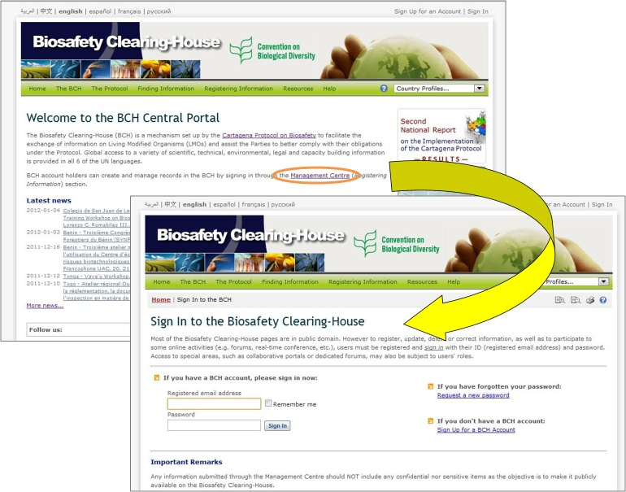

Figure

Latest News

The *news* links posted in this area provide details of new processes and facilities in the Central Portal, as well as details of events, reports and other information relevant to the BCH and CPB. A complete list of BCH news is available at https://bch.cbd.int/about/news/ and can be reached by following the link to **More news.**

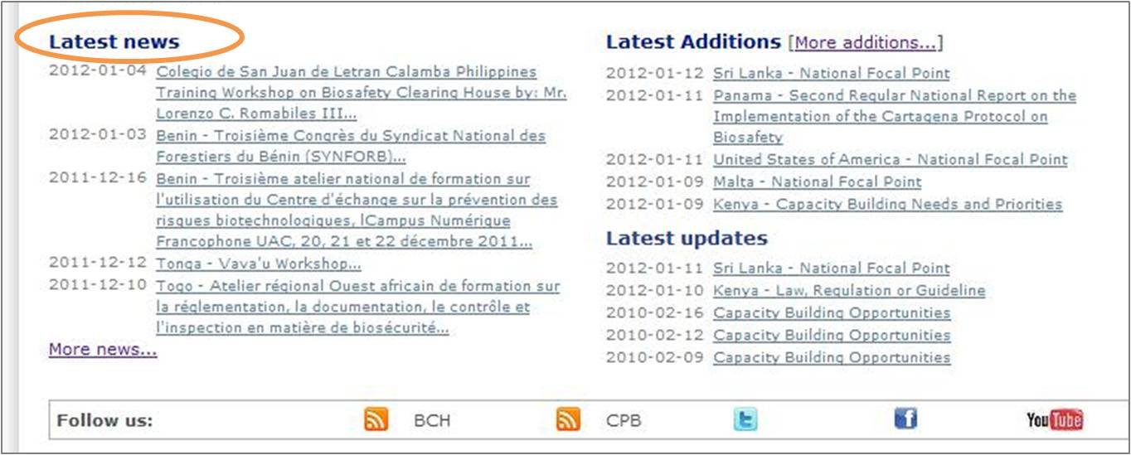Figure

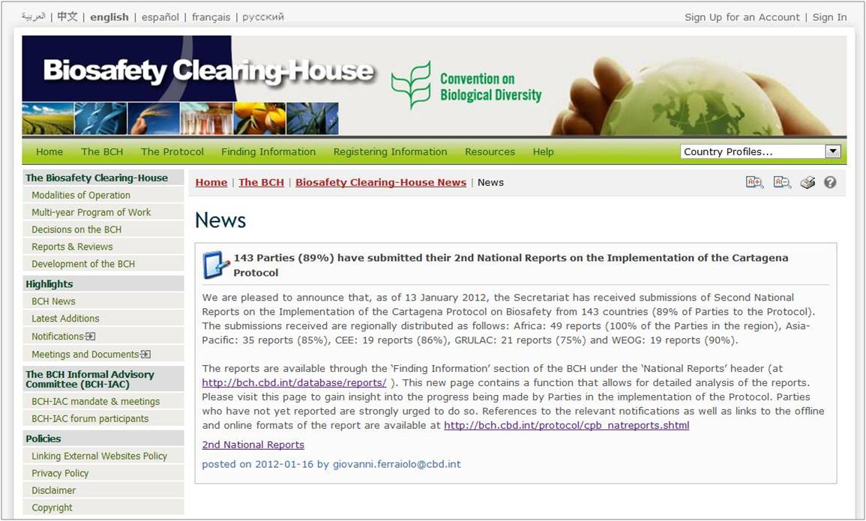

Figure

Latest Additions

The most recent additions to the BCH databases are displayed on this list. The list is updated every six hours and the five most recent entries are shown in the Home page. An extended list of BCH additions is available at <https://bch.cbd.int/about/latestadditions.shtml> and can be reached by following the link to **More additions.**

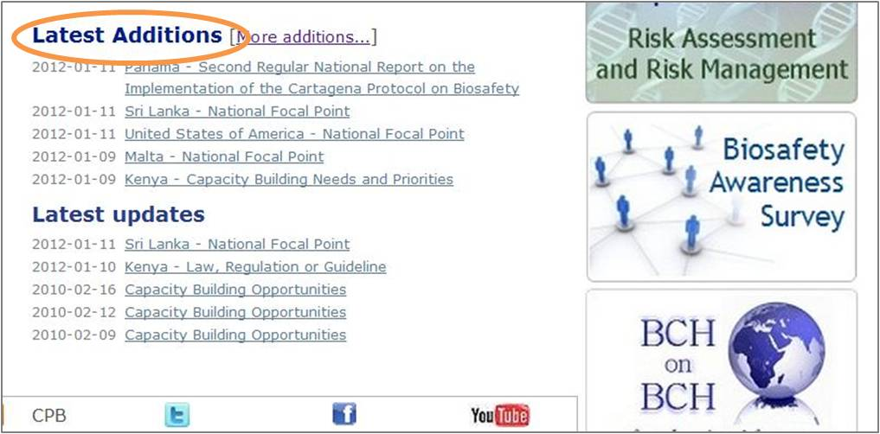

Figure

In many instances, after clicking on **More >>**, the Search results page displayed is longer than a standard computer screen and the user needs to scroll down the page to view all the items and links to additional search result pages if there are any.

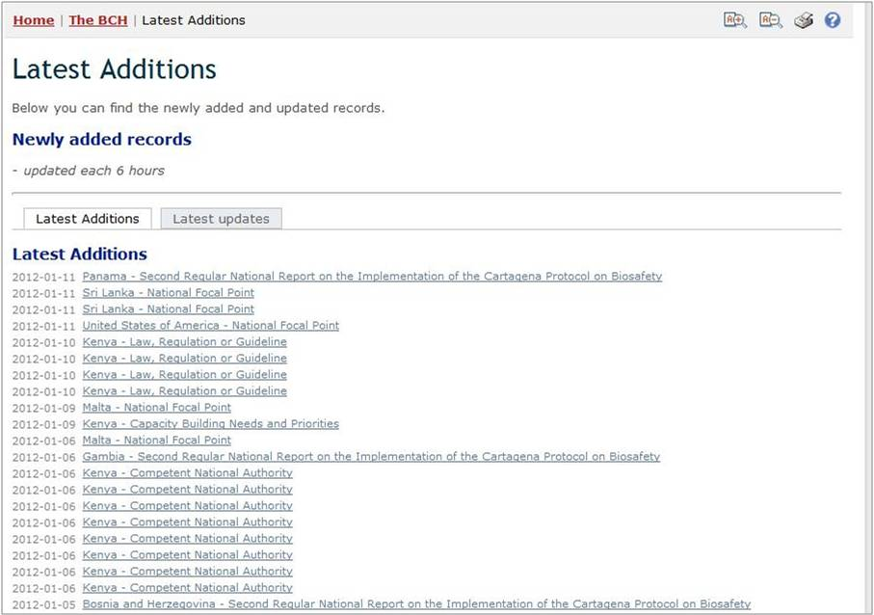

Figure

Latest Updates

The most recent updates of the records registered in the BCH are displayed in this section. The list is updated every six hours and the five most recent updates are shown in the Home page. An extended list of BCH updates is available along with the most recent additions at <https://bch.cbd.int/about/latestadditions.shtml> and can be reached by following the link to **More additions.**

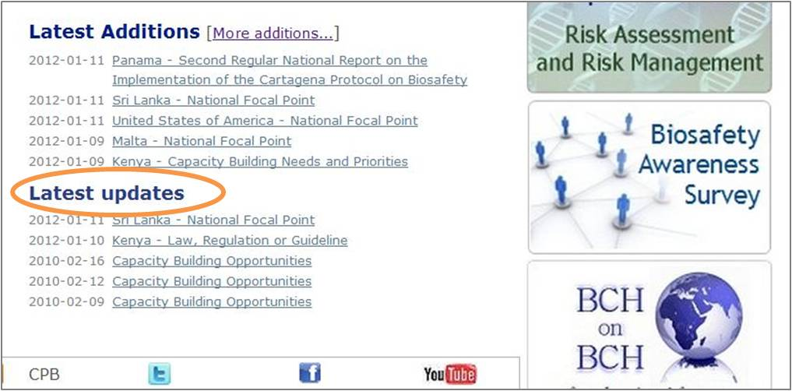

Figure

The Navigation Bar

Above the welcome area of the Home page there is a navigation bar that provides links to the major components of the BCH.

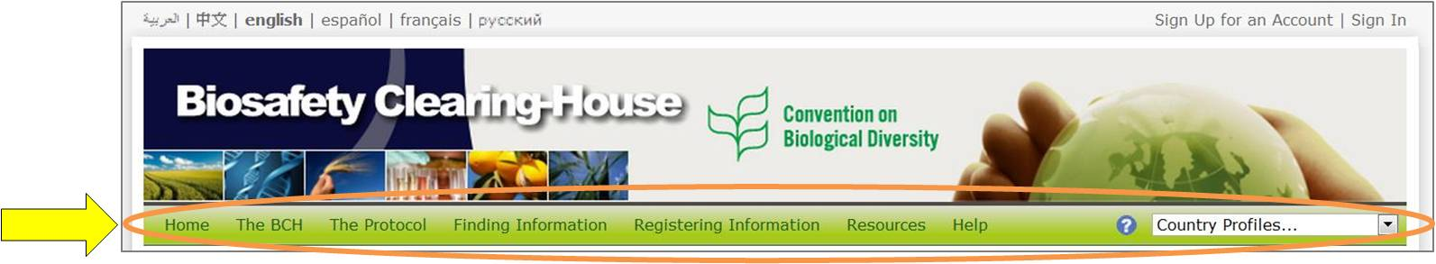

Figure

**The BCH** section provides links to information about the BCH, its development and management, highlights and policies.

**The Protocol** section provides links to information about the Protocol, including text of the Protocol, key issues, lists of Parties to the Cartagena Protocol and Supplementary Protocol on Liability and Redress, COP-MOP Decisions, National reports, meetings, publications, and notifications.

**The Finding Information section** provides links to search pages for the different categories of information in the BCH databases and to compiled information (i.e. National Contacts, the LMOs Registry, the Organism Registry and the Gene Registry).

**The Registering Information** menu entry is a link to the Management Centre, through which BCH users can create and manage their information. The access to the Management Centre is limited to registered users who have to “Sign in” with their Registered email address and Password.

**The Resources** section provides access to other useful site resources such as (i) the Common Formats used in the BCH, (ii) a page describing the Solutions for National Participation (Hermes and the BCH Ajax Plug-In), (iii) Training Site of the BCH, (iv) the Glossary, (v) the Thesaurus; (vi) the Site map (vii) Offline copy of the BCH, (viii) LMO quick-links, (ix) Online forums and portals, (x) Interoperability services and (x) the available Mailing lists.

**The Help** section provides access to the BCH Online Help System main page and some specific sections within it, namely: (i) Help on help, (ii) BCH Central Portal, (iii) Complete BCH Help Manuals, (iv) Training materials, as well as additional training resources found directly in the BCH: (v) BCH tutorials, (vi) Frequently Asked Questions, and (vii) Training Site of the BCH.

On the right side of the navigation bar there is a search box for locating country profiles. This provides a quick search function to locate all records for each country listed.

The menus on the BCH Central Portal use icons to illustrate aspects of the associated links. The commonly found menu icons include:

*  link to a website page 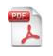link to a PDF document
* link to a MS Word document
*  link to a page in another section of the BCH
*  link to a page in another website (e.g. CBD website)

Details of more icons used on the BCH Central Portal are provided in the Ready Reference 04 guide available in the following URL:

<http://bch.cbd.int/help/trainingmaterials/En/06)%20Ready%20Reference%20Guides/RR04En.pdf>

The “Country Profiles”

URL: <http://bch.cbd.int/>

All pages of the BCH provide a quick search facility to obtain country profiles. The link is provided on the right hand side of the navigation bar. The drop down menu allows the user to select a country and display a summary of all the records entered in the BCH by that country.

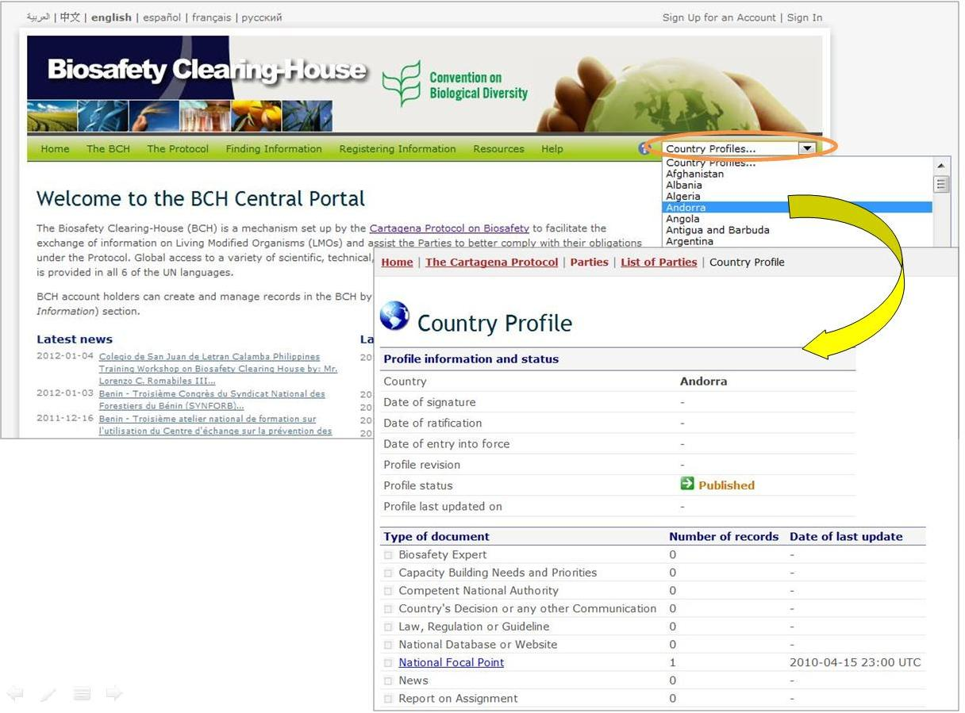

Figure

The country profiles contain information about each country, including: Date of signature; Date of ratification; Date of entry into force; Profile revision; Profile status and the last date in which the profile was updated. It lists the types of documents registered (e.g. National Focal Point, Law, regulation or guideline, Risk assessment, etc.) and the amount of records registered of each type, with links to access those records. The number of records for each type of documents, as well as the date of the last update, are indicated.

The BCH

URL: http://bch.cbd.int/about/

The introductory page for the “The BCH” section explains the Mandate of the BCH, provides some background information about the development of the site and about Strategic Plan for the Cartagena Protocol. The information about the BCH is divided into the following sections:

1. **The Biosafety Clearing-House**, setting out its Modalities of Operation, Multi-year Program of Work, Decisions on the BCH, Reports and Reviews, and Development of the BCH;
2. The BCH Collaborative Portal, hosting discussions of several groups that are directly involved in the implementation of the BCH mechanism, including the BCH Informal Advisory Committee (BCH-IAC), Forum of National Focal Points (BCH on BCH) and UNEP-GEF BCH Projects.
3. **Highlights**, providing BCH News, Latest Additions, Notifications, and Meetings and Documents;
4. **Policies,** providing information about Linking External Websites Policy, Privacy Policy, **Disclaim**er, and Copyright.

The content of the BCH section is accessed from the menu on the left side of The Biosafety Clearing-House page, or from **The BCH** drop down menu on the navigation bar.

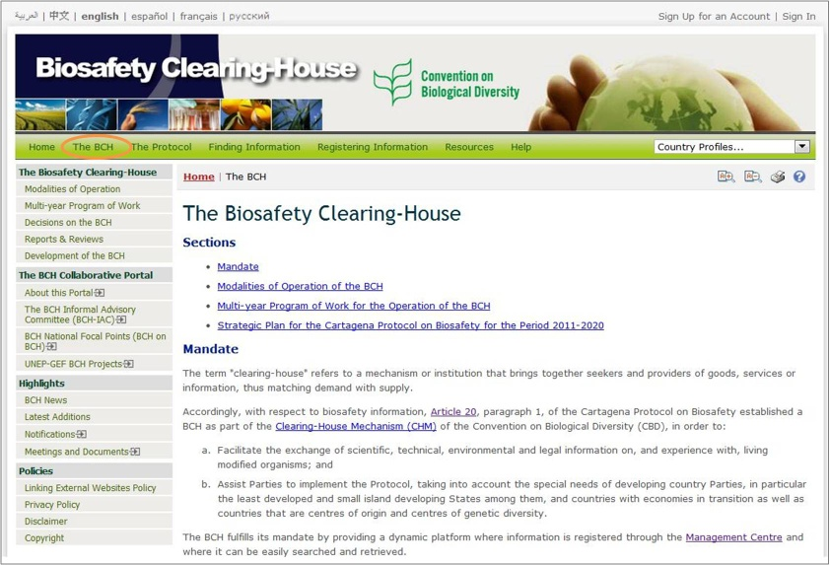

Figure

### Biosafety Clearing-House

This section of the BCH Central Portal provides links to information about development and operation of the BCH.

#### Modalities of Operation

The link for **Modalities of Operation** takes the user to a page which provides information about the BCH functions and the roles of the institutions that participate in its establishment, maintenance and use. Notably in this page there are sections about “The role of the National Focal Points for the BCH” and the category of information that, at a minimum, the Biosafety Clearing-House has a role in providing access to.

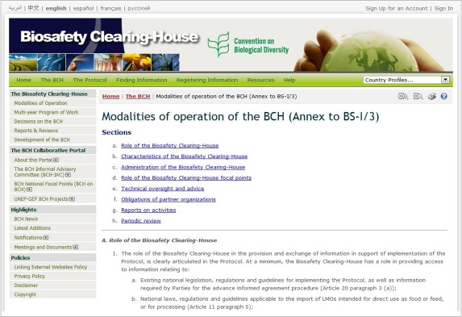

Figure

#### Multi-year Program of Work

The link for the **Multi-year Program of Work** takes the user to a page which outlines the establishment and maintenance of the major components of the BCH.

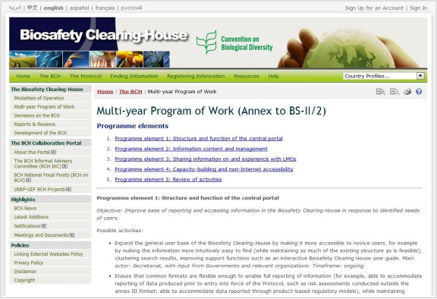

Figure

The Multi-year Program of Work page provides information about the objectives and possible activities for each program element as decided by the COP-MOP.

#### Decisions on the BCH

The link for **Decisions on the BCH** takes the user to a page which provides links to all BCH decisions taken by COP-MOP as well as at ICCP meetings that were held before the entry into force of the Cartagena Protocol.

Quick links to particular COP-MOP or ICCP meetings are located at the top of the page allowing easier navigation.

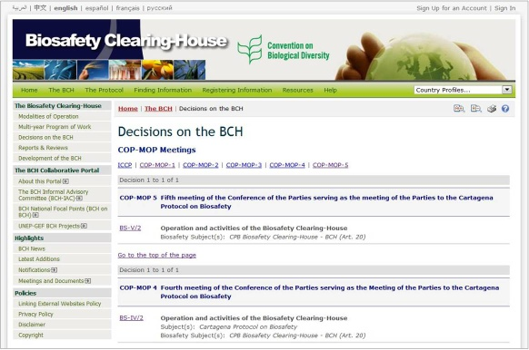

Figure

#### Reports and Reviews

This link takes the user to a page in which reports on the activity of the BCH are published. These reports comprise **BCH Log Reports** (number of records and visits per year), **BCH Annual Reports**, and **User surveys, feedback and other publications on the BCH.**

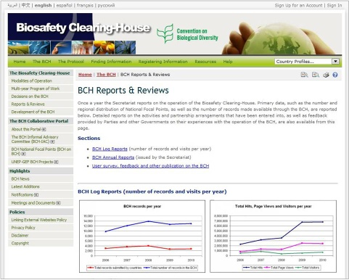

Figure

#### Development of the BCH

The link for Development of the BCH takes the user to a page which provides information about stages of development of the BCH from 2003 to the present. For example, the 2009 release of new versions of the BCH Management Centre, Common Formats, and FAQs, as shown in the picture below. Quick links to particular year are displayed at the top of the page allowing easier navigation.

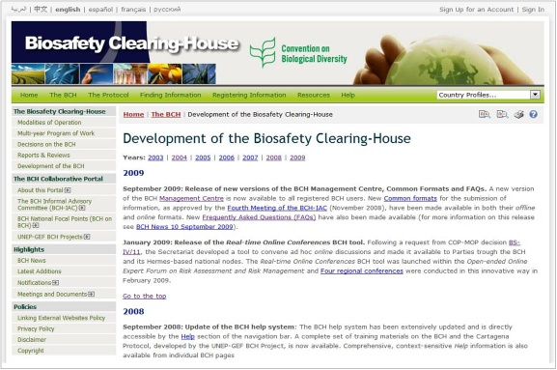

Figure

### The BCH Collaborative Portal

This section of the BCH hosts discussions of several groups that are directly involved in the implementation of the BCH mechanism as established under Article 20 of the Cartagena Protocol. Online discussions of the following groups are currently available at the BCH Collaborative:

* The BCH Informal Advisory Committee (BCH-IAC)
* The Forum of the BCH National Focal Points (BCH on BCH)
* The UNEP-GEF BCH Projects and Regional Advisors (RAs) Forum

These on-line forums can also be found in the **Resources** section of the BCH. Some of the forums are visible by the general public (the BCH on BCH Forum), while others are restricted to specific BCH registered users. In all cases users have to sign in to be able to fully participate.

#### About this Portal

The introductory page for the BCH Collaborative Portal provides brief information about the portal and lists the groups currently engaged in online discussions. The user can access the web-pages of the listed discussion groups using the left-hand menu or links in the text of the Introduction page.

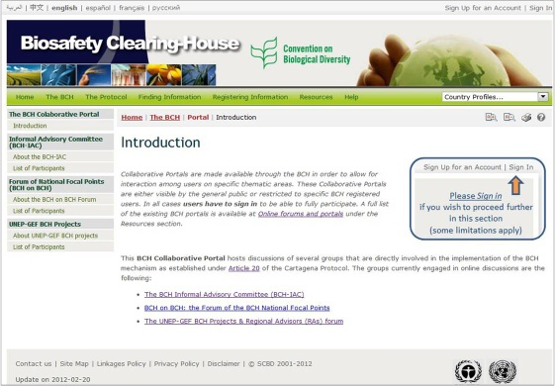

Figure

#### The BCH Informal Advisory Committee (BCH-IAC)

In this sub-section the user will find information on the BCH Informal Advisory Committee (BCH-IAC). This committee provides guidance to the Executive Secretary with respect to resolution of technical issues associated with the ongoing development of the Biosafety Clearing-House.

The **About the BCH-IAC** link in the left-hand menu of the BCH Collaborative Portal takes the user to the BCH Informal Advisory Committee (BCH-IAC) page**.** This page provides information about the IAC, the mandate of the IAC, the meeting documents and summaries of the outcomes of each meeting. It also provides links to the BCH-IAC Forum. Note that access to the forum is limited to IAC members only.

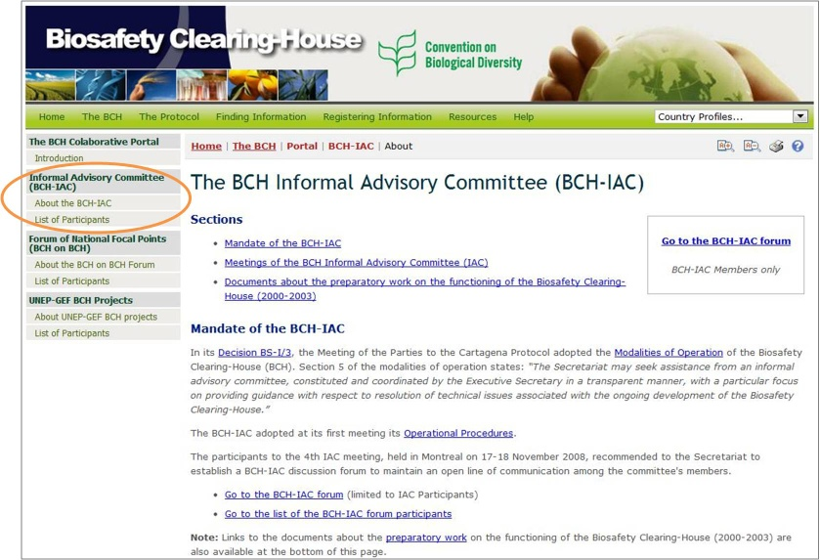

Figure

The **List of Participants** link in the left-hand menu takes the user to the page that displays the current list of participants of the BCH-IAC forum.

#### Forum of National Focal Point (BCH on BCH)

The BCH on BCH Forum is dedicated to all National Focal Points (CPB-NFPs and BCH-NFPs) and National Authorized Users (NAUs) and aims to promote better exchange of information and sharing of views and experiences on the current status on the BCH through online discussions. The forum is visible by the general public, but posting is limited to NFPs and NAUs. The discussion is organized in sub-regional groups.

The **About the BCH on BCH Forum** link in the left-hand menu of the BCH Collaborative Portal takes the user to the BCH on BCH Forum page that provides brief information about the forum and link to the online discussions. The **List of Participants** link in the left-hand menu takes the user to the page that displays the current list of participants of the BCH on BCH forum.

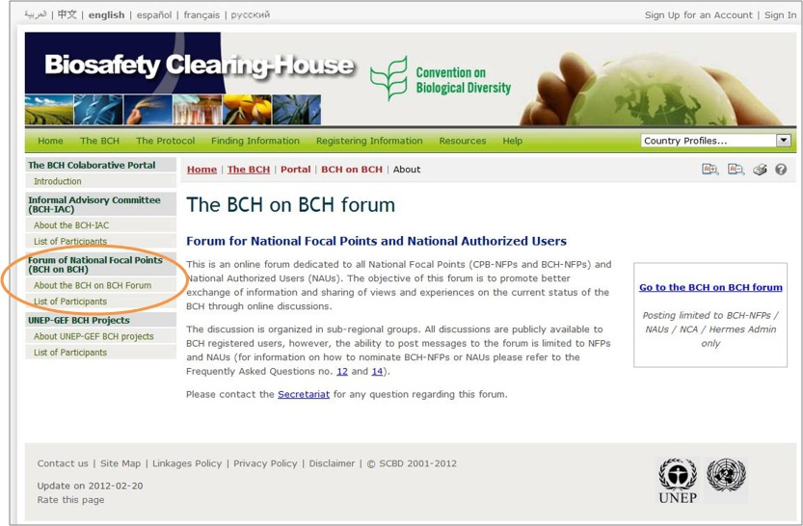

Figure 18

#### UNEP-GEF BCH Projects

The UNEP-GEF BCH Forum is designed to assist the UNEP-GEF Regional Advisors of the BCH Project in their tasks. The forum is restricted to UNEP-GEF project and Regional Advisors.

The **About UNEP-GEF BCH Projects** link in the left-hand menu of the BCH Collaborative Portal takes the user to the UNEP-GEF BCH Projects page that provides brief information about the forum and link to the online discussions. The **List of Participants** link in the left-hand menu takes the user to the page that displays the current list of participants of the UNEP-GEF BCH forum.

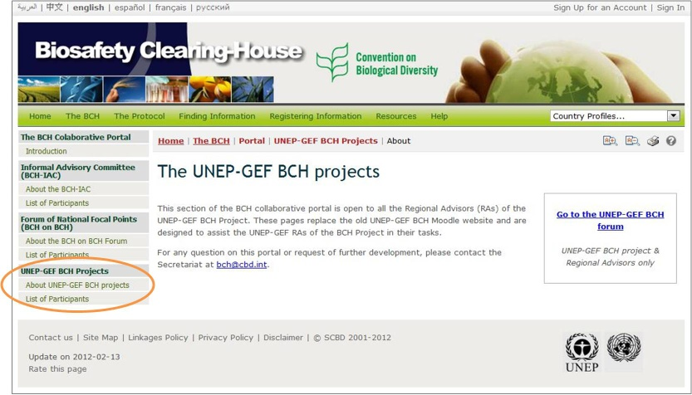

Figure

### Highlights

This section of the BCH Central Portal provides links to information about the activities of the BCH and the Cartagena Protocol.

#### BCH News

The **BCH News** link takes the user to the Biosafety Clearing-House News page. It provides updates on changes to the BCH Central Portal, as well as news on the BCH and the Cartagena Protocol. Registered users can register BCH news using the BCH Management Centre mechanisms for registering information, either through the online registration form for BCH News or through the offline Common Format for BCH News.

Below the Biosafety Clearing-House News page title, there are four buttons: the orange RSS - Subscribe to the BCH and Cartagena Protocol News buttons, the light blue Follow Us on Twitter button, and the blue Follow Us on Facebook button. The RSS buttons provide a news feed URL that can be used to subscribe to the BCH and Cartagena Protocol News using an RSS reading tool. The Twitter button takes the user to the Cartagena Protocol page on Twitter, and the Facebook button to the page on Facebook where the user can also stay up-to-date with latest news on the BCH, the Cartagena Protocol and the Nagoya - Kuala Lumpur Supplementary Protocol on Liability and Redress.

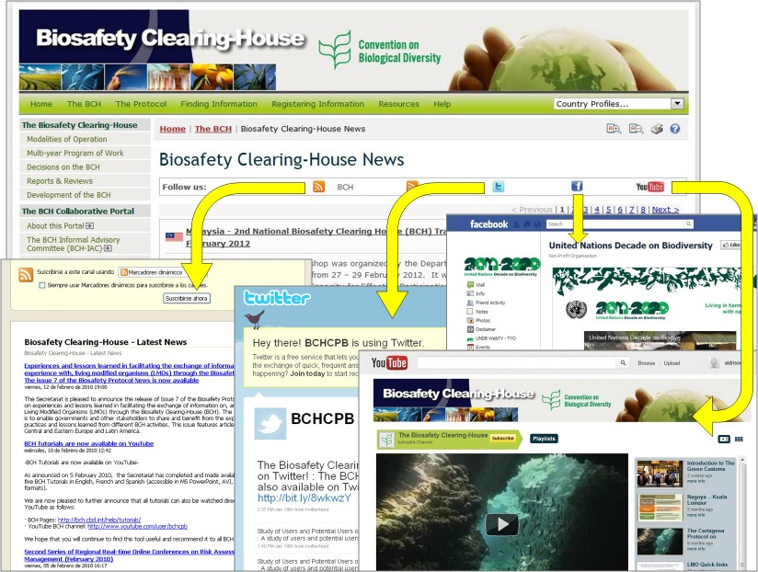

Figure

#### Latest Additions

The **Latest Additions** link takes the user to a page that displays the most recent additions to the databases. The information is updated every six hours.

Selecting a **Record ID** takes the user to the record page.

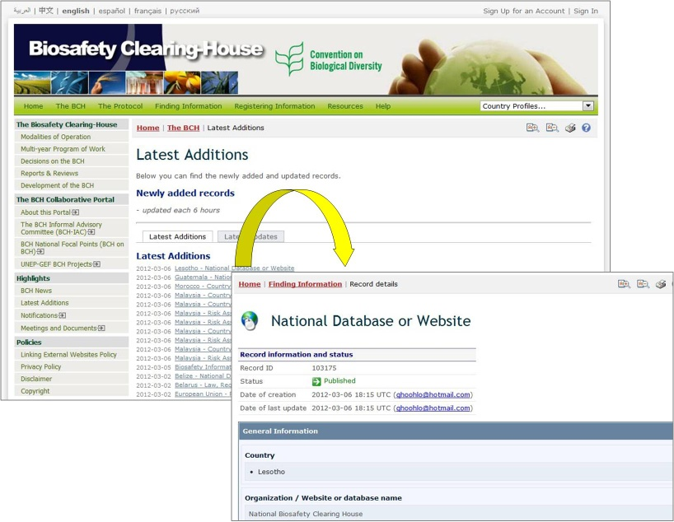

Figure

#### Notifications

This link takes the user to the Cartagena Protocol Notifications page, which is under the “The Protocol” section of the BCH. See “The Protocol” → “Notifications”.

#### Meetings and Documents

This link takes the user to the Cartagena Protocol Meetings page, which is under the “The Protocol” section of the BCH. See “The Protocol” → “Meetings and Documents”.

### Policies

The section on Policies provides links to information about the linking of external websites policy, the privacy policy for the BCH, a disclaimer, and the copyright statement of the BCH.

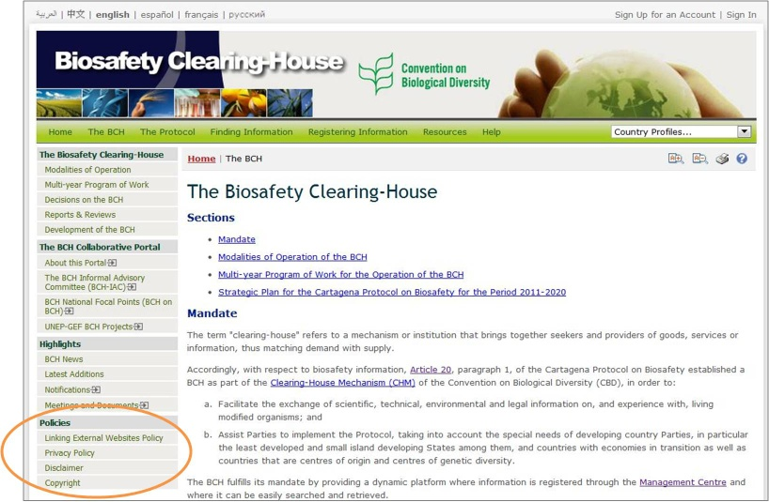

Figure

.

#### Linking External Websites Policy

The link for **Linking External Websites Policy** takes the user to a page which details how the Secretariat considers and selects sites for inclusion in the BCH Central Portal.

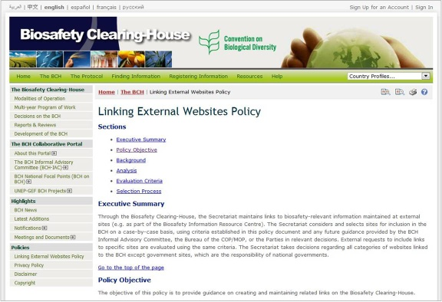

Figure

#### Privacy Policy

The link to **Privacy Policy** takes the user to a page which details how information submitted to the BCH is handled and how the BCH manages information about visitors to the BCH Central Portal.

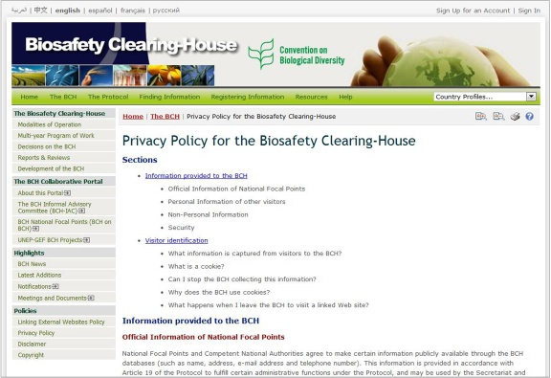

Figure

#### Disclaimer

The link to **Disclaimer** takes the user to apage which notes that while every effort is made to provide accurate information, the accuracy of the information provided through the BCH is not guaranteed. Parties to the Convention, Governments and any other users of the database are encouraged to bring errors, inaccuracies and omissions to the attention of the Secretariat.

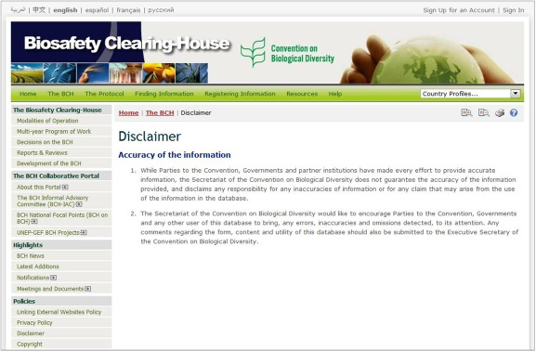

Figure

#### Copyright

This link takes the user to the Copyright page, which contains the copyright statement for the BCH website.

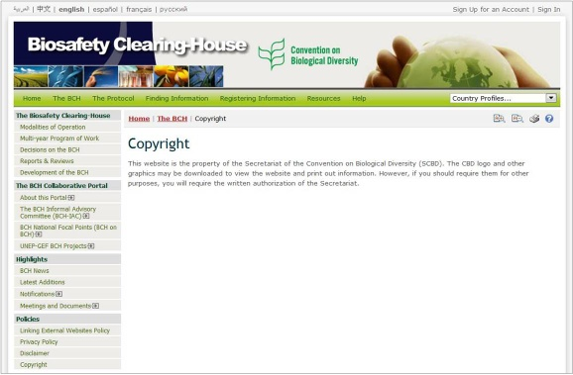

Figure

The Protocol

URL: <http://bch.cbd.int/protocol/>

The **Protocol** link on the navigation bar takes the user to the Cartagena Protocol on Biosafety page that provides access to information about the Cartagena Protocol on Biosafety.

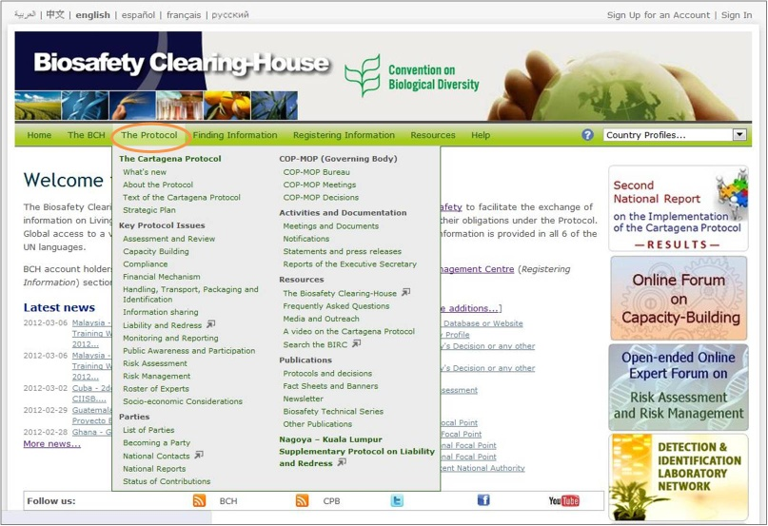

Figure

The Cartagena Protocol on Biosafety page is divided into sections that provide:

1. A brief introduction to the Protocol;
2. News about the Protocol and possibility to follow them via RSS service, as well as on Twitter, Facebook and YouTube Channel;
3. List of the latest Press releases, notifications and upcoming meetings;
4. Current number of Parties and the latest ratifications of the Protocol;
5. Reports on SCBD activities, including quarterly reports, bi-annual newsletter, and monthly bulletin;
6. News and updates on biodiversity and biosafety;
7. Access to information about the United Nations Decade on Biodiversity, including Factsheets on the Cartagena Protocol and Nagoya-Kuala Lumpur Supplementary Protocol on Liability and Redress.

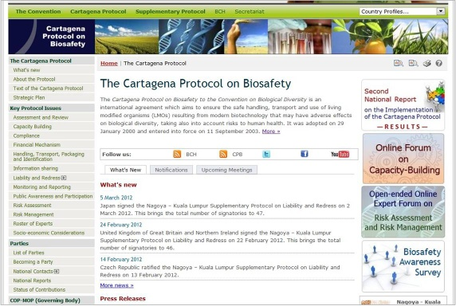

Figure

On the right side of the The Cartagena Protocol on Biosafety page the user can find shortcuts to important and/or recently added sections. The left hand menu on the page provides information in several areas:

1. The Cartagena Protocol;
2. Key Protocol Issues
3. Parties;
4. COP-MOP (Governing Body);
5. Activities and Documentation;
6. Resources;
7. Publications
8. Nagoya-Kuala Lumpur Supplementary Protocol on Liability and Redress.

The Cartagena Protocol

This part of the “The Protocol” section provides links to information about the Cartagena Protocol, its key issues and Strategic Plan.

#### What’s new

The link to **What’s new** takes the user to a page that provides list of news on the Cartagena Protocol on Biosafety ordered by date. By clicking on the news title, the user enters a corresponding page or document. The user can also subscribe/follow the CPB and BCH news on Twitter, Facebook or through RSS by clicking on the icons displayed at the top of the page.

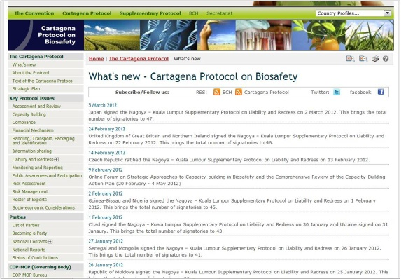

Figure

#### About the Protocol

This section provides a brief introduction to the Protocol and a short history of its development. It also explains the ICCP process and provides a timeline of the Cartagena Protocol.

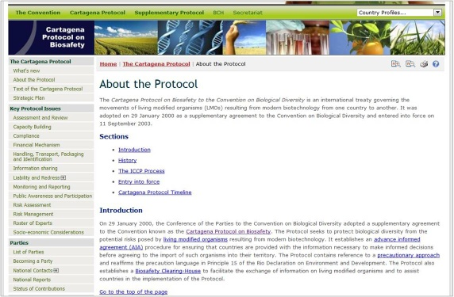

Figure 30

#### Text of the Protocol

The **Text of the Protocol** link takes the user to a page which provides a link to the **Downloadable files** page where you will find the complete text of the Cartagena Protocol on Biosafety in the six official United Nations languages and in PDF format. Links are also provided to web pages reporting the text of each article of the Protocol.

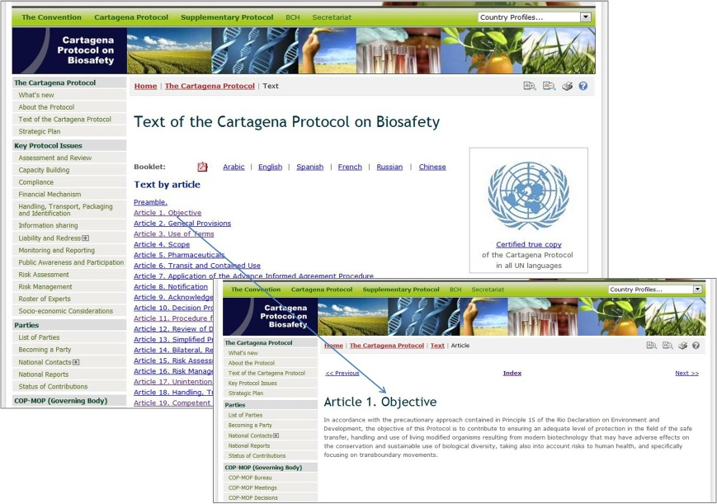

Figure

#### Strategic Plan

The link to **Strategic Plan** takes the user to a page that provides introduction to the Strategic Plan for the Cartagena Protocol for the period 2011-2020, its vision and mission. The link **Go to the Strategic Plan** can be found below the introduction and takes the user to a page with the full text of the Plan. The text of the Plan can also be accessed by selecting the link **Adopted Text** from the left hand menu. The left hand menu for the **Strategic Plan** section also provides the links to the **What has been done**, **Decisions** and **Relevant Documents** sections.

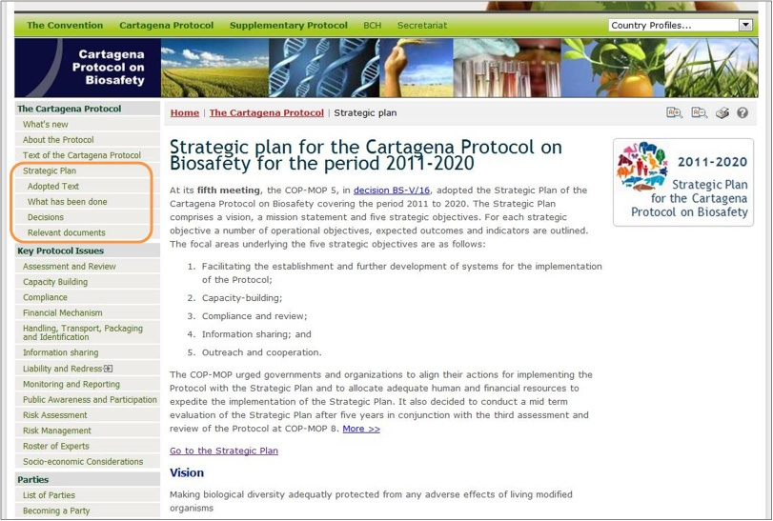

Figure 32

### Key Protocol Issues

The **Key Protocol Issues** section provides links to information on the key issues that are being addressed by the Conference of the Parties serving as the meeting of the Parties to the Protocol (COP-MOP).

The key issues under the Cartagena Protocol on Biosafety include:

* Assessment and Review
* Capacity Building
* Compliance
* Financial Mechanism
* Handling, Transport, packaging and Identification
* Information-Sharing
* Liability and Redress
* Monitoring and Reporting
* Public Awareness and Participation
* Risk Assessment
* Risk Management
* Roster of Experts
* Socio-economic Considerations

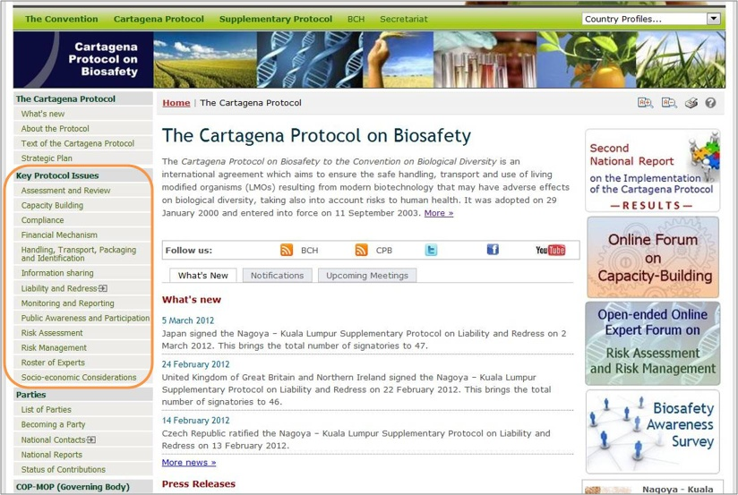

Figure

More information on the key protocol issues can be found by selecting a key issue from the left-hand menu or drop-down menu of the Cartagena Protocol on Biosafety page.

Parties

This section provides information about Parties to the Cartagena Protocol and signatories to its Supplementary Protocol, procedures for becoming a Party, as well as compiled data on National Contacts and Competent Authorities, National Reports, and status of contributions to the Trust Funds.

#### List of Parties

The link for **List of Parties** takes the user to the Parties to the Protocol and signatories to the Supplementary Protocol pages which provide summaries of the *status of ratification* and *entry into force* for each Party to the Protocol. There are two tabs on the top of the page: Cartagena Protocol on Biosafety and Nagoya – Kuala Lumpur Supplementary Protocol on Liability and Redress that allows the user switching to the corresponding page. The introductory paragraph on each page is followed by the table that lists countries that have signed, ratified, accepted, approved or acceded to the Protocol and the date at which the Protocol entered into force in each country. Each country name provides a link to the Country Profile, which provides summary information about all records registered in the BCH by that country.

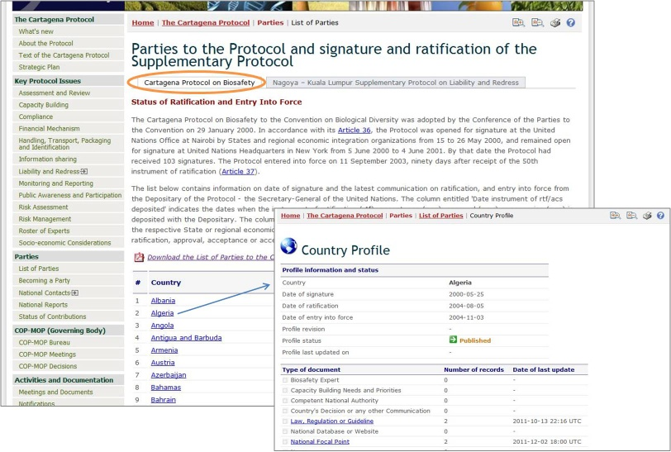

Figure

#### Becoming a Party

This section provides information on procedures for deposit of the instrument or ratification, acceptance, approval or accession with the Depositary along with the model instruments of ratification, acceptance, approval or accession. Treaty Handbook prepared by the Treaty section of the Office of Legal Affairs and Model instruments of ratification, acceptance, approval or accession can be downloaded in six official UN languages and in PDF format by following the links displayed in the right section of the page.

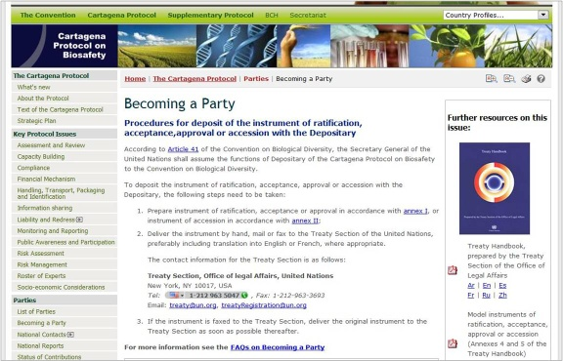

Figure

#### National Contacts

This link takes the user to the National Contacts & Competent Authorities page, which is under the “Finding Information” section of the BCH (**Compiled Information** – National Contacts). The page provides access to contact lists in PDF format for the following types of contacts: i) list of Parties to the Cartagena Protocol on Biosafety, ii) all National Contacts under the Cartagena Protocol on Biosafety, iii) Cartagena Protocol National Focal Points, iv) Biosafety Clearing-House National Focal Points, v) Points of contact for unintentional transboundary movements and emergency measures, and vi) Competent National Authorities.

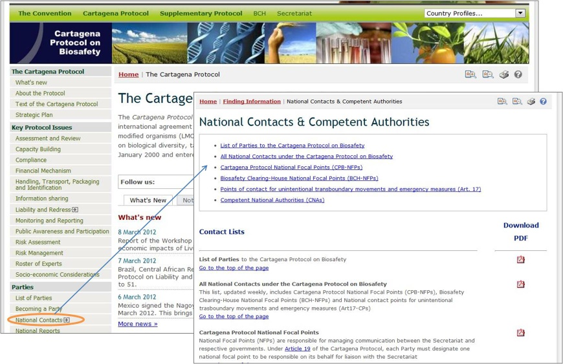

Figure

#### National Reports

The **National Reports** link takes users to the National Reports page that provides access to [National Reports on Implementation of the Cartagena Protocol on Biosafety](https://bch.cbd.int/protocol/reporting/#natrep): Interim National Report (2005), First National Report (2007), and Second National Report (2011). A summary of the submission of National Reports by regions is provided at the top of the page.

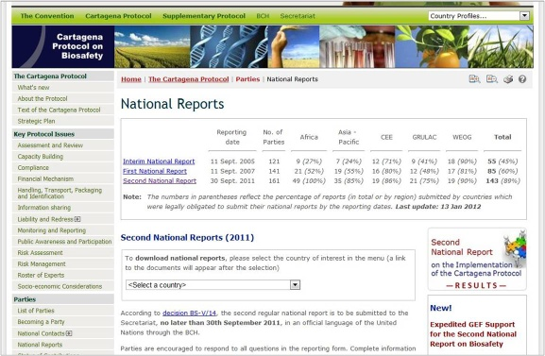

Figure

National reports on the implementation of the Protocol can be accessed by selecting a country from the drop-down menu in the text. The user can also download the reporting form for the Second National Report, which is available in Ms Word format in six official UN languages. Instructions on submission of Second National Reports as well as a link to the online form can be found under the subsection **Second National Reports (2011)**

The **National Repo**rts section also provides links to the National Reports pages with Analyzer. This is an electronic facility which is intended to assist users to aggregate and analyse data according to selected Parties, geographic areas, economic groups and other criteria.

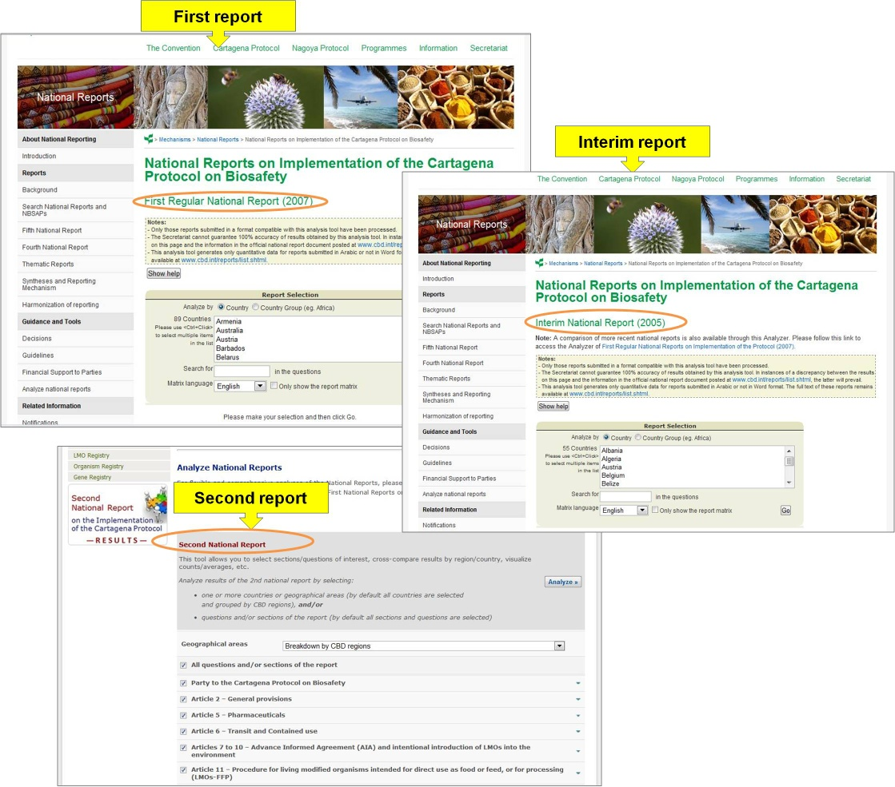

Figure

On the Analyzer, the user can refine the search using known words in the questions or selecting the matrix languages used for the analyses (Interim and First National Reports Analyzer) or by selecting specific section(s) or question(s) from the report (Second National Report Analyzer). Selecting the Go (Interim and First National Reports Analyzer) or Analyze (Second National Report Analyzer) button calls up the search results..

#### Status of Contributions

The link for **Status of Contributions** takes the users to a page that provides information about status of contributions to the Trust Funds of the Cartagena Protocol on Biosafety: i) the General Trust Fund (BG Trust Fund) for the Core Programme Budget for the Cartagena Protocol on Biosafety, ii) the Special Voluntary Trust (BH) Trust Fund for the Additional Voluntary Contributions in Support of Approved Activity, and iii) the Special Voluntary Trust Fund (BI Trust Fund) for Facilitating Participation of Developing Country Parties, in particular the Least Developed and the Small Island Developing States amongst them, and Parties with Economies in Transition.

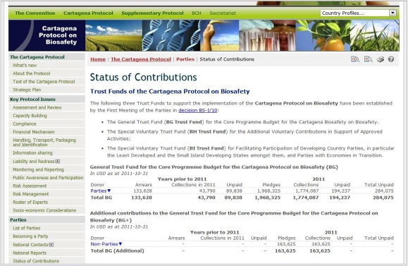

Figure

COP-MOP (Governing Body)

This part of the **“The Protocol**” section of the BCH provides information about COP-MOP Bureau, meetings and decisions.

#### COP-MOP Bureau

The **COP-MOP Bureau** link takes the user to a page with the contact information of current (COP-MOP 5) Bureau Members. This section also provides links to the Bureau Online Collaborative Portal and Minutes of past COP-MOP Bureau Meetings, available in PDF format.

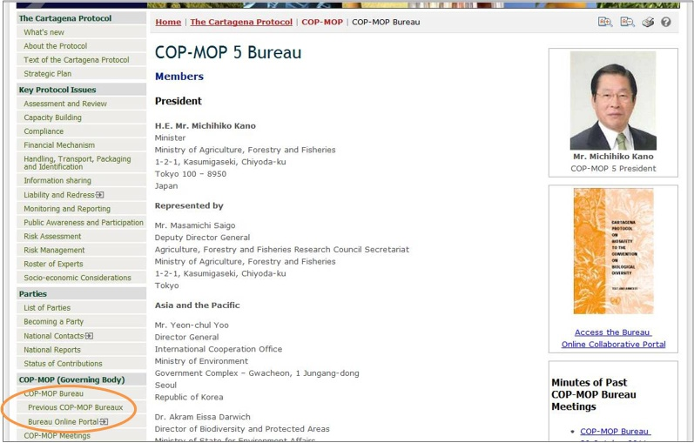

Figure

#### COP-MOP Meetings

The link for **COP-MOP Meetings** takes the user to a page that provides information about meetings of the Conference of the Parties serving as the meeting of the Parties to the Protocol (COP-MOP). The COP-MOP currently meets every two years in conjunction with the regular meetings of the Conference of the Parties (COP) to the Convention on Biological Diversity.

To date, the COP-MOP has held five meetings that are listed at the top of the page along with the ICCP Process. Clicking on the title of the meeting will take the user to the section of the page devoted to the corresponding COP-MOP meeting. This section provides links to related documents, including final report and meetings documents, COP-MOP decisions available in several official UN languages, and other related links, such as Press releases, Webcasting and Speeches.

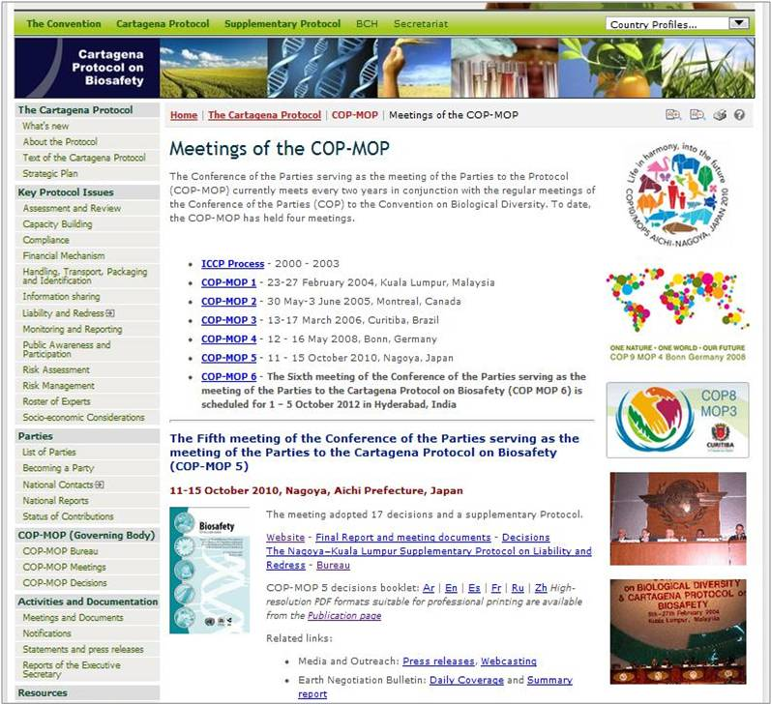

Figure

#### COP-MOP Decisions

The link for **COP-MOP Decisions** takes the user to a search page for finding any decision taken at any COP-MOP meeting as well as the entire list of decisions divided into sections that correspond to the different COP-MOP meetings. The user can also download a COP-MOP decisions booklet, which is available in PDF format for all COP-MOP meetings and in several official UN languages. Links for the booklets are provided in the right section of the page. High-resolution PDF format files suitable for professional printing are also available from the **Publication** page.

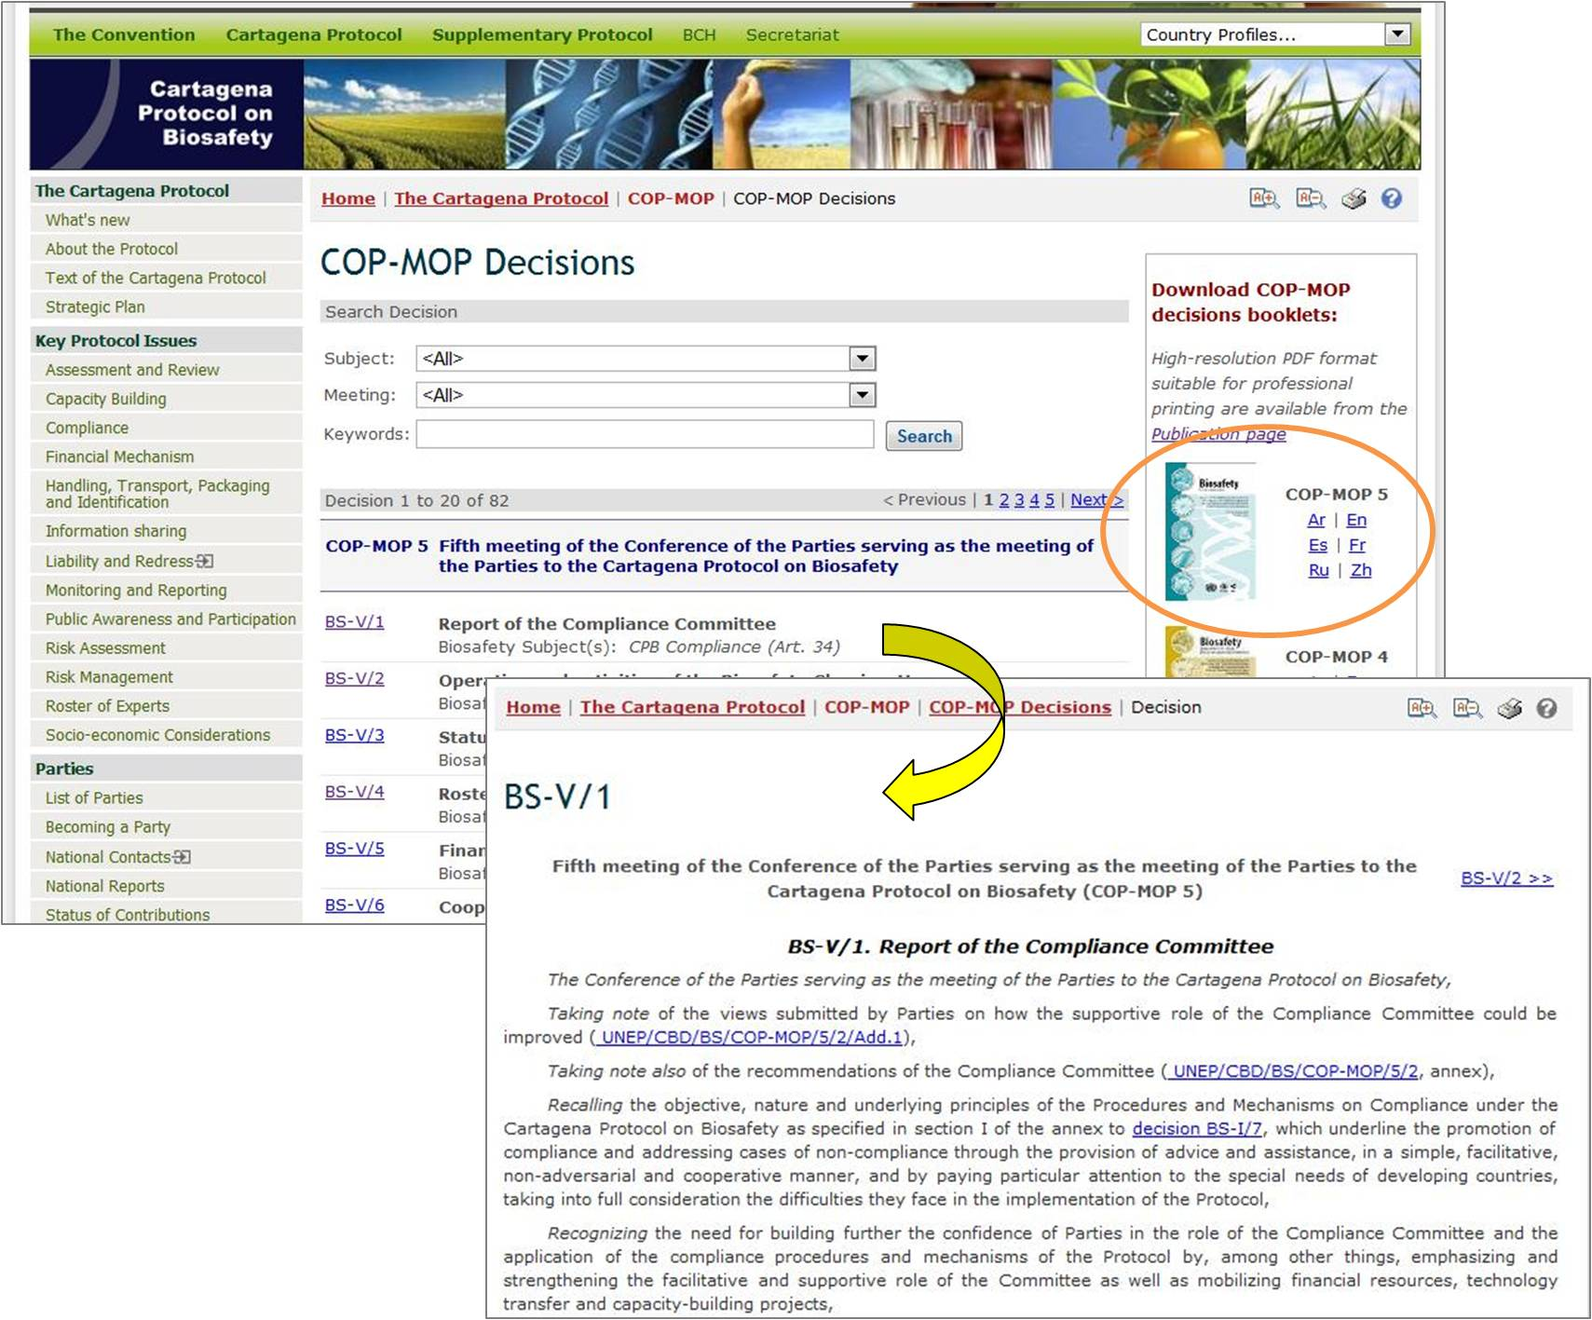

Figure

The search criteria include biosafety-related subjects, a choice of COP-MOP meeting, and keywords or words in the title.

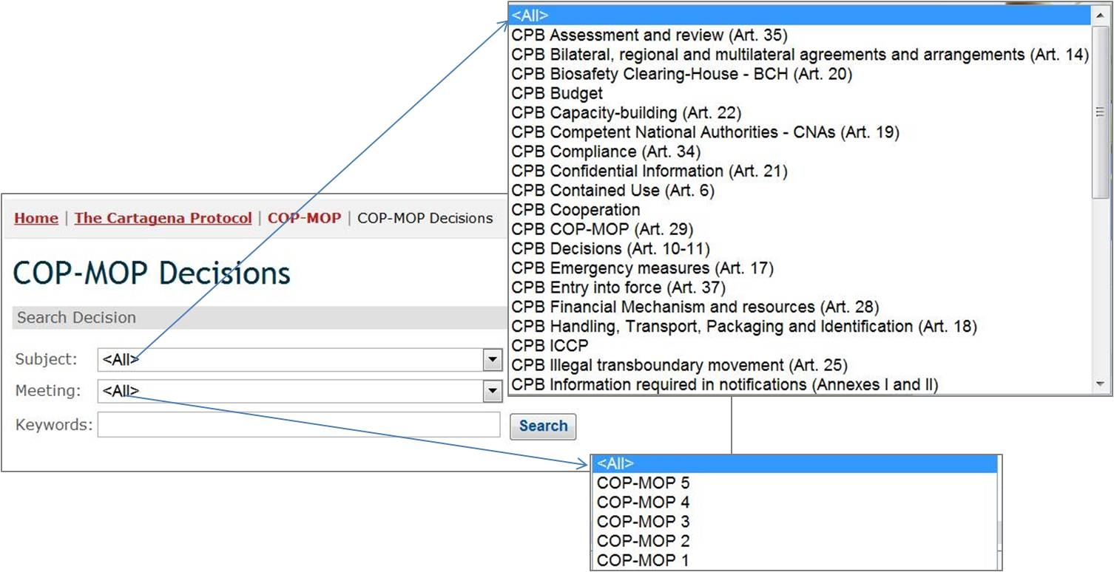

Figure

Activities and Documentation

This part of the **“The Protocol**” section provides information about Cartagena Protocol Meetings and related documents, Cartagena Protocol Notifications, Messages, Statements and Press Releases, as well as Reports of the Executive Secretary.

#### Meetings and Documents

The link to **Meetings and Documents** takes the user to a page that provides a search facility to locate meetings related to specific aspects of the CBD.

Below this search facility you will find the entire list of COP-MOP meetings divided into two sections: Upcoming meetings, where the user can find the details of upcoming meetings such as date, place, etc, and Previous meetings, in which the list of all past meetings can be found.

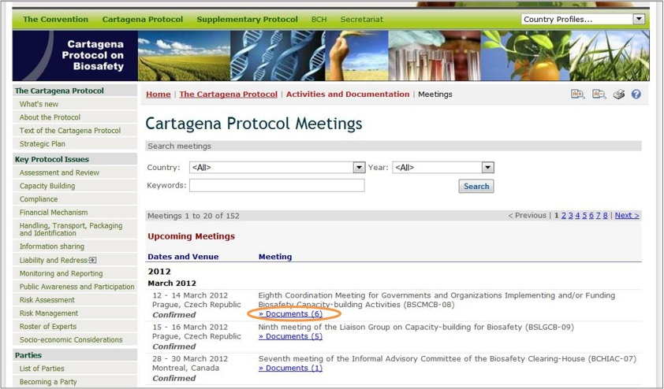

Figure

By clicking on the Documents link, the user enters a page that displays all available documents related to that meeting.

#### Notifications

The **Notifications** link takes the user to a search page that can be used to find notifications issued by the CBD Secretariat. To search for Notifications filed under the Protocol, insert a keyword in the **Keyword Box** and /or use **Year** dropdown list. Click on the Search button to obtain the search results.

Below the search facility you will find a list containing all Notifications ordered by date.

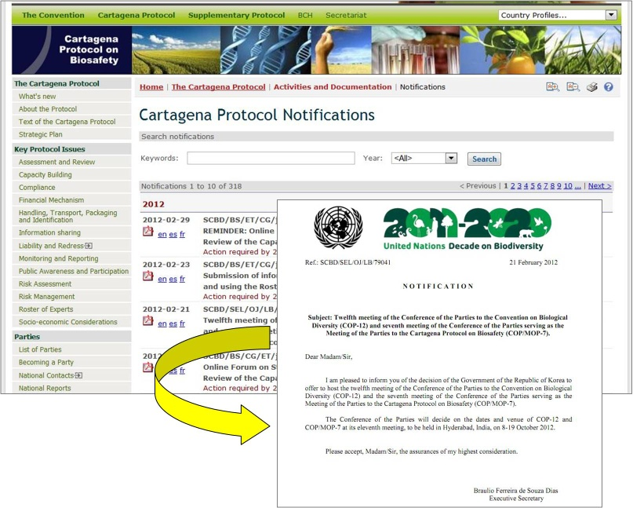

Figure

#### Statements and Press Releases

The **Statements and Press Releases** link takes the user to a page that displays a list of messages, statements and press releases ordered by date. By clicking on the press releases title, the user enters a page that displays corresponding document. By following the link to **More Press Releases,** the user enters a search page that can be used to find press releases issued by the CBD Secretariat. To search for press releases under the Cartagena Protocol, select “Cartagena Protocol on Biosafety” as a subject, insert a keyword in the **Title Contains** boxand /or use **Year** dropdown list and / or **Reference** box. Click on the Go button to obtain the search results.

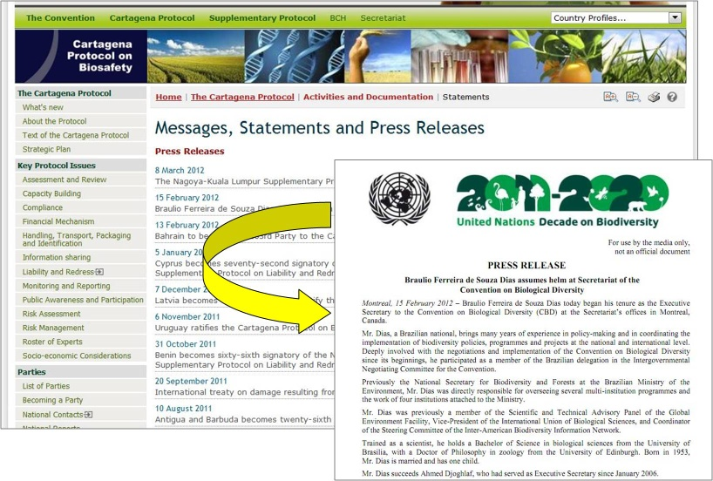

Figure

#### Reports of the Executive Secretary

The link to **Reports of the Executive Secretary** takes users to a page where they can find the Reports of the Activities of the Secretariat on the Implementation of the Work Programme of the Convention and its Protocol. These reports are prepared by the Executive Secretary of the Convention on the execution of its functions and cover the activities carried out by the SCBD for the implementation of the work Programme of the Convention and its Protocol. The Reports are provided by the Secretariat at the end of each calendar year and can be accessed by selecting the year of interest in the search box. Selecting a year from the dropdown list allows the user to download the full Report in PDF format. Annual reports (starting from 2006) can also be downloaded by clicking the corresponding shortcuts at the page.

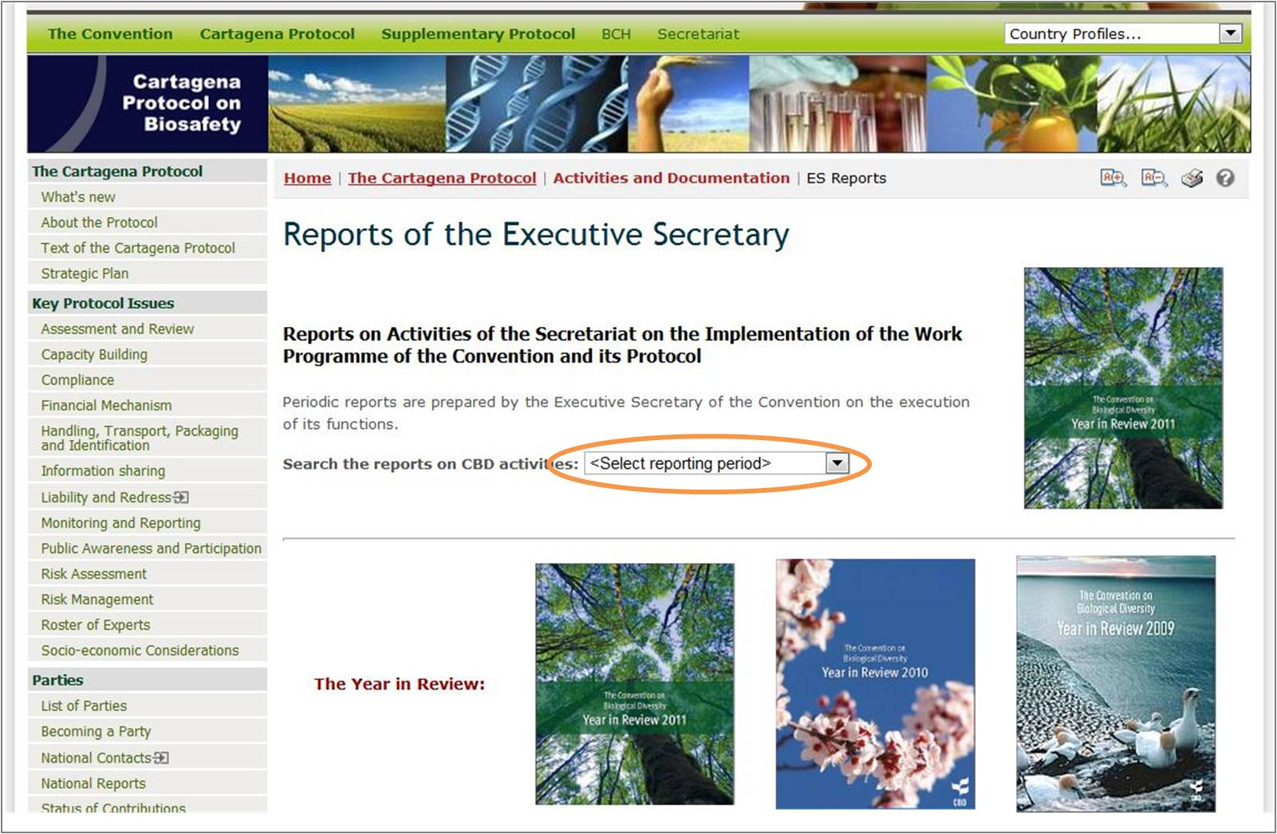

Figure 48

Resources

This part of **“The Protocol**” section provides links to the Biosafety Clearing-House section, the Frequently Asked Questions page, the Media and Outreach section, a video on the Cartagena Protocol, and a search page for the Biosafety Information Resource Centre (BIRC).

* **The Biosafety Clearing-House**: this link takes the user to the BCH section that is under “The BCH” section of the BCH. See the section of this Manual**.**
* **Frequently Asked Questions**: this link takes the user to the **Frequently Asked Questions (FAQs) on the Cartagena Protocol** page that is under the “Resources” section of the BCH. See the section of this Manual.
* **Media and Outreach**: this link takes the user to a page that provides links to various resources for media and public that aim to increase visibility of the Protocol and to inform and engage different target audiences. The page also displays **What’s New** and **Notifications** sections that are under the “The Cartagena Protocol**”** section of the BCH.
* **A video on the Cartagena Protocol**: this link takes the user to a page that displays video on the Cartagena Protocol. The video is also available for download in MP4 (80 Mb) and WMV (40 Mb) formats or from the YouTube BCH Channel. Links for download can be found at the bottom of the page.
* **Search the BIRC**: this link takes the user to a search page of the Biosafety Information Resource Center (BIRC) that is under the “Finding Information” section of the BCH. On this page the user can search for electronic catalogues of biosafety-related publications and information resources. For further information see Manual 04.

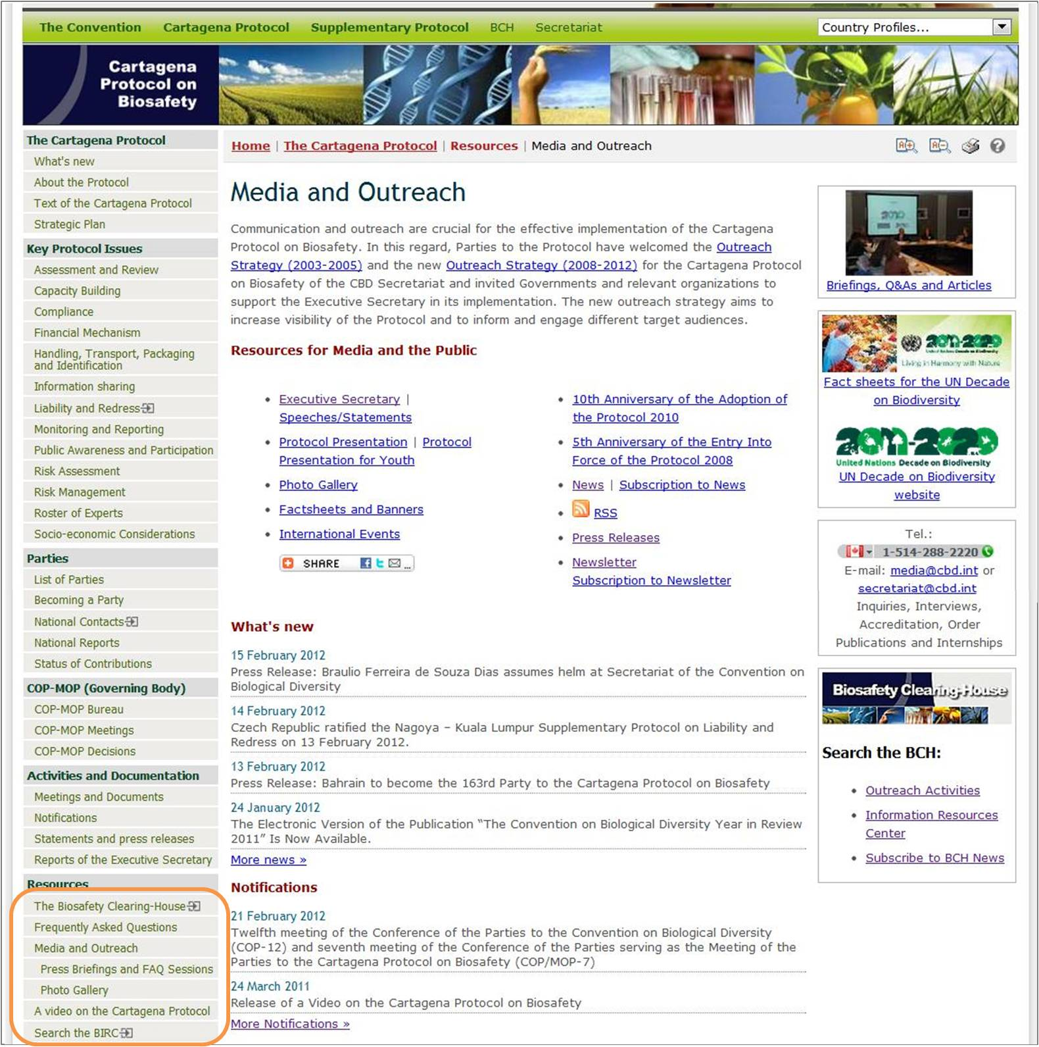

Figure

Publications

This part of **“The Protocol**” section provides links to various publications, including Protocols, Decisions booklets, Fact Sheets and Banners, Biosafety Protocol Newsletter, and other publications.

* **Protocols and Decisions**: this link takes users to a page where they can download the Cartagena Protocol on Biosafety and the Nagoya – Kuala Lumpur Supplementary Protocol on Liability and Redress booklets, as well as COP-MOP decisions booklets. Protocols and COP-MOP 1 booklets are available in all six official UN languages in PDF format. Other COP-MOP decisions booklets are available in several or one UN language(s). All files are also available in high-resolution PDF format suitable for professional printing and can be downloaded by selecting the file from the drop-up menu at the bottom of the page.
* **Fact Sheets and Banners**: this link takes users to a page where they can download fact sheets and banners on various issues, including the Cartagena Protocol on Biosafety, Information Sharing and the Biosafety Clearing-House, Risk Assessment and Management, Public Awareness and Public Participation, Socio-Economic Considerations, and others. Size of the files can be found under the shortcuts for publications. Some publications are available both in high- and low-resolution PDF formats.
* **Newsletter**: this link takes users to a page where they can download issues of the **Biosafety Protocol Newsletter**. The page lists issues of the Newsletter along with their titles. For some issues a high-resolution version in PDF format is available for download. The user can subscribe to the Newsletter by following the **Subscription to Newsletter** link that takes the user to the “Sign In to the Biosafety Clearing-House” page and then to “My subscriptions” page that is under the “Management Centre” section of the BCH (see Manual 06).
* **Other Publications**: this link takes users to a page where they can download a number of publications, including “The Cartagena Protocol on Biosafety: A record of the negotiations”, “An Explanatory Guide to the Cartagena Protocol on Biosafety (by IUCN)”, “Biosafety and the Environment”, and others. Most of the publications are available in several UN languages. The page also provides links to videos: “The Cartagena Protocol on Biosafety”, “BCH Tutorials”, and “LMO quick-links”.

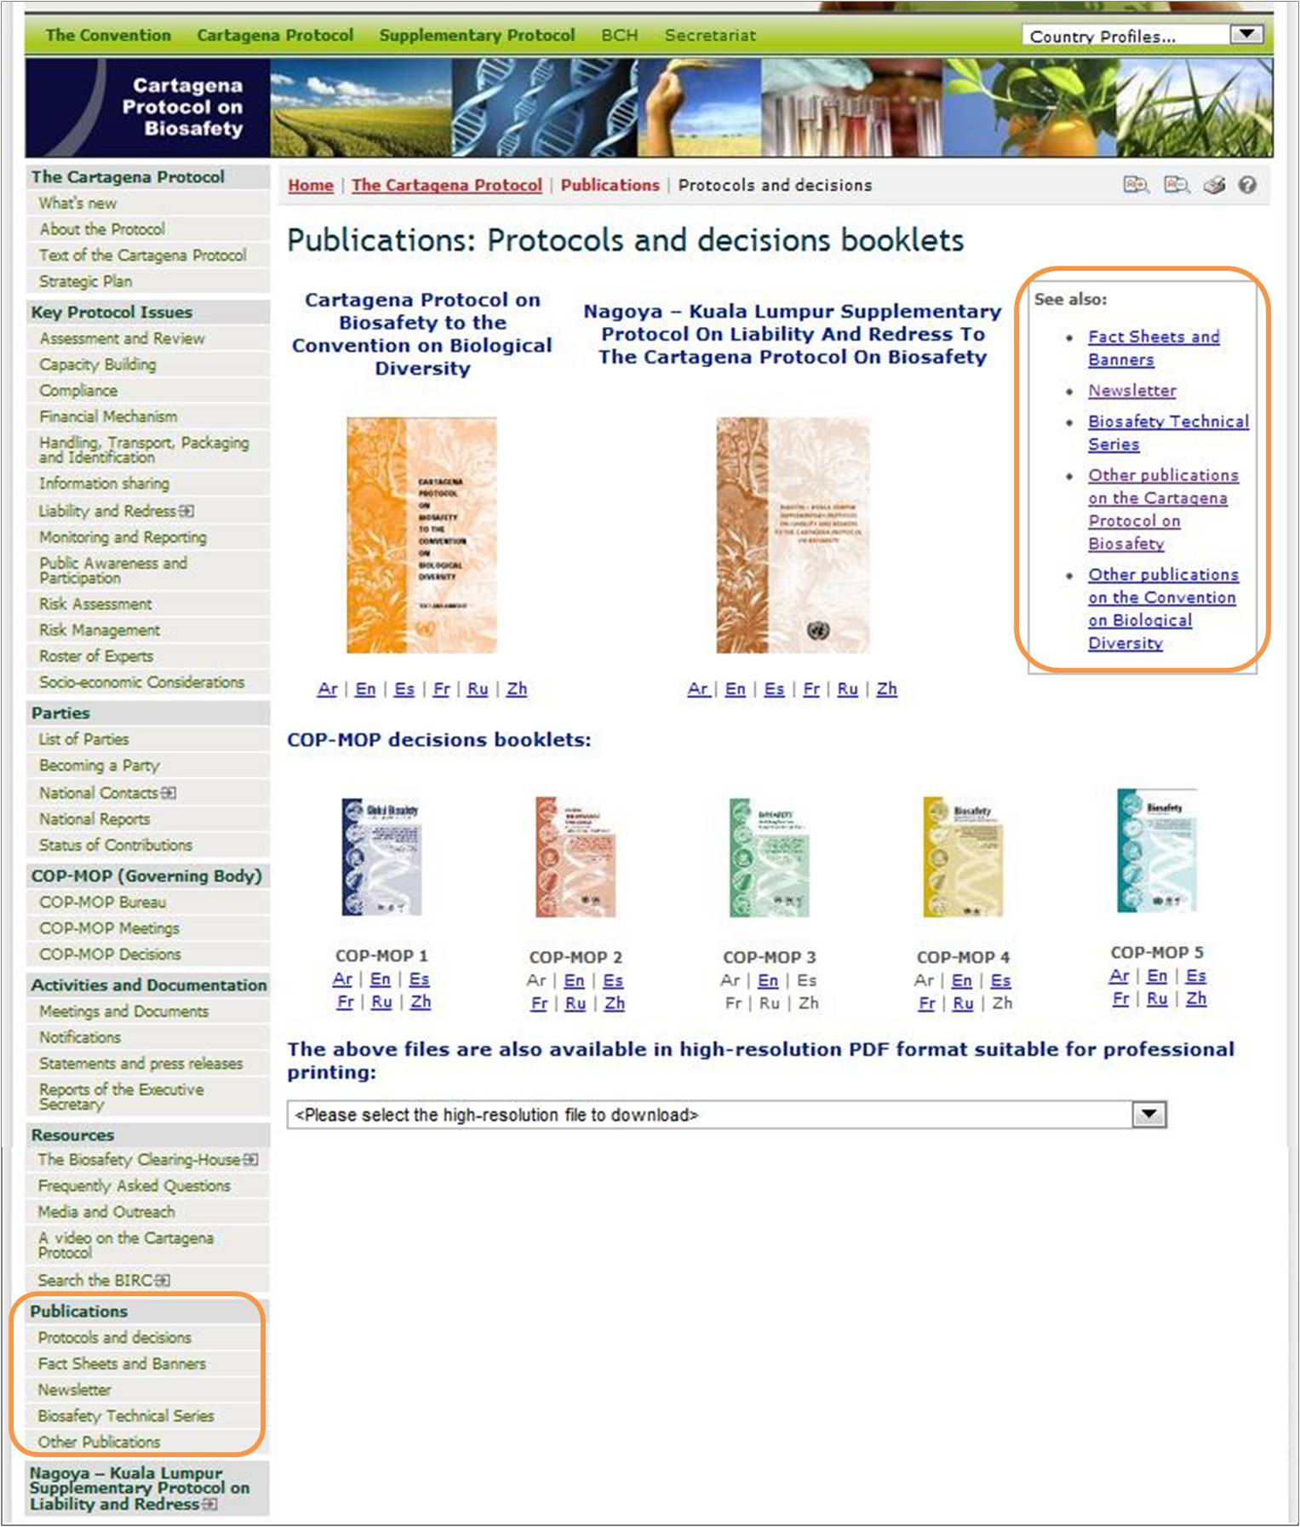

Figure

Nagoya - Kuala Lumpur Supplementary Protocol on Liability and Redress

By clicking the link to **Nagoya – Kuala Lumpur Supplementary Protocol on Liability and Redress**, the user enters a page that provides access to information about the Nagoya – Kuala Lumpur Supplementary Protocol on Liability and Redress to the Cartagena Protocol on Biosafety. The page provides introductory information which is followed by the section **What’s new** containing the latest news on the Supplementary Protocoland the **Notifications** sectioncontaining the latest notifications**.**

The left hand menu provides links to the following sections:

* Press Release
* Text of the Nagoya – Kuala Lumpur Supplementary Protocol
* Regional Workshops
* Relevant Decisions
* Relevant Documents
* List of Signatories
* Becoming Party

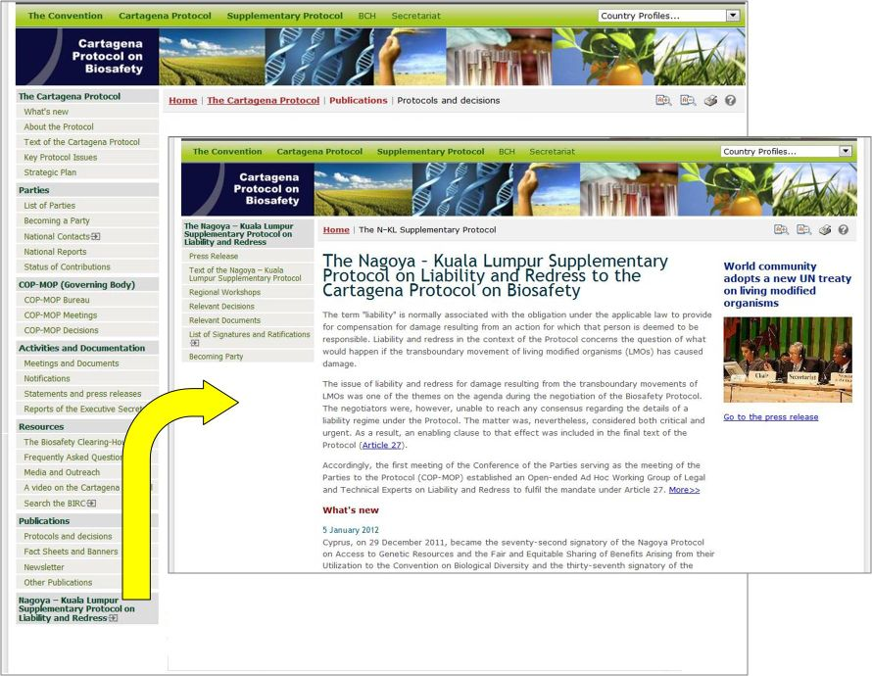

Figure

Finding Information

URL*:* <http://bch.cbd.int/database/>

The links to categories of information in the databases of the BCH Central Portal are provided in the **Finding Information** drop down menu on the navigation bar.

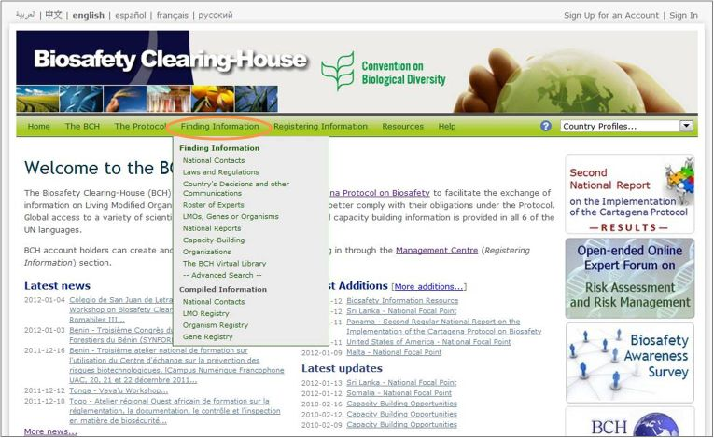

Figure

Each category listed on this page links to a search page that is designed to easily find specific information. From each search page it is also possible to browse all records in any of the categories by using a Browse all records button.

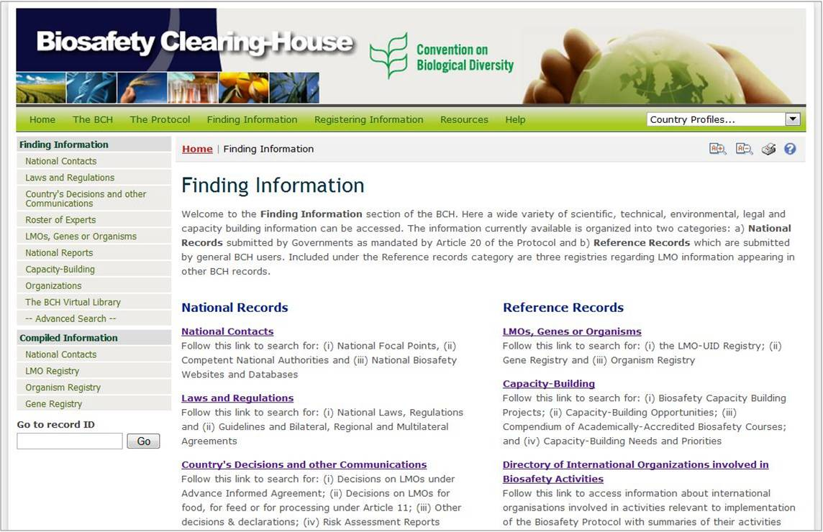

Figure

The types of data stored in the BCH databases and the instructions for finding information in the BCH are explained in Manual 04.

Registering Information

URL: <https://bch.cbd.int/member/signin.shtml>

The BCH Management Center provides a web-based mechanism to register, update, delete or correct information in the BCH databases. Information related to national implementation of the Protocol, which is stored in national records, can only be registered by BCH National Focal Points. The following categories of national records can be registered:

* Second Regular National Report on the Implementation of the Cartagena Protocol on Biosafety
* National Biosafety Website or Database
* Competent National Authority (Article 19.2)
* Biosafety Law, Regulation, Guidelines & Regional and International Agreements
* Country's Decision or any other Communication
* Risk Assessment Generated by a Regulatory Process
* Biosafety Expert (Decisions BS-I/4 and BS-IV/4)
* Report on the assignment undertaken by the Biosafety Expert

Information for reference records can be submitted by any BCH registered user. These records must be validated by the SCBD before they can become public.

* Contact Details
* Capacity Building Activities, Projects and Opportunities
* Capacity Building Needs Assessment
* Biosafety Organization including Laboratory for detection and identification of LMOs
* Biosafety Information Resource Centre (BIRC)
* BCH News
* Risk assessment generated by an independent or non-regulatory process
* Living Modified Organism (LMO)
* Genetic element
* Organism

The Secretariat reserves the right to review and verify, prior to publication, all reference records submitted by BCH registered users

Detailed instructions on using the Management Centre are provided in Manual 06.

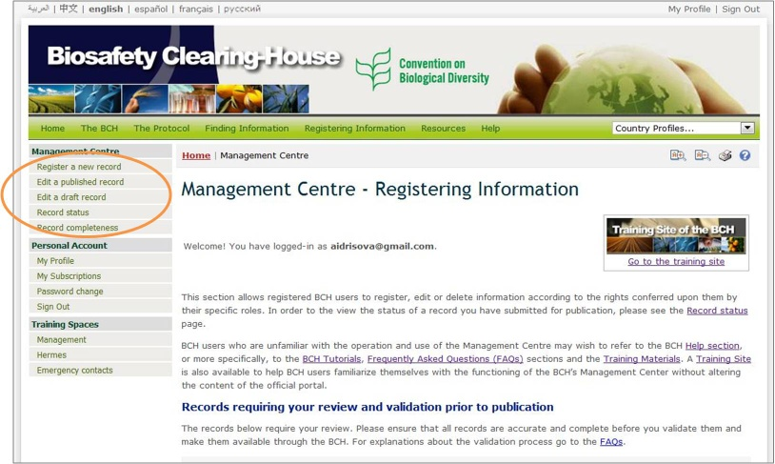

Figure

Resources

URL: <http://bch.cbd.int/resources/>

The BCH Resources page of the BCH Central Portal contains sections which are meant either to help the user to interact with the Central Portal or to provide more general biosafety-related information. They are as follows:

1. Common formats;
2. Solutions for National Participation (Hermes and the BCH Ajax Plug-In);
3. BCH Training Site
4. Glossary;
5. Thesaurus;
6. Site Map;
7. Offline copy of the BCH;
8. LMO Quick-links
9. Online Forums and Portals
10. Interoperability Services Documentation; and
11. Mailing List

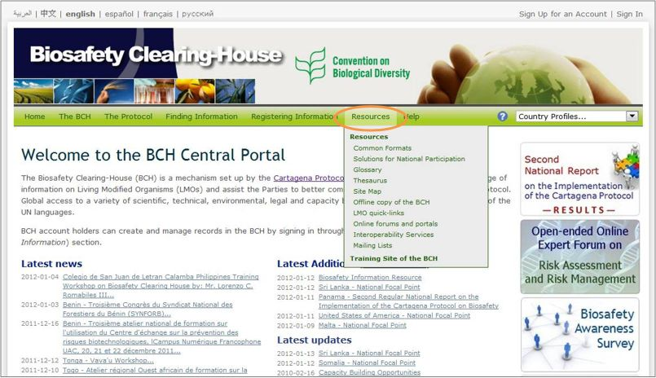

Figure

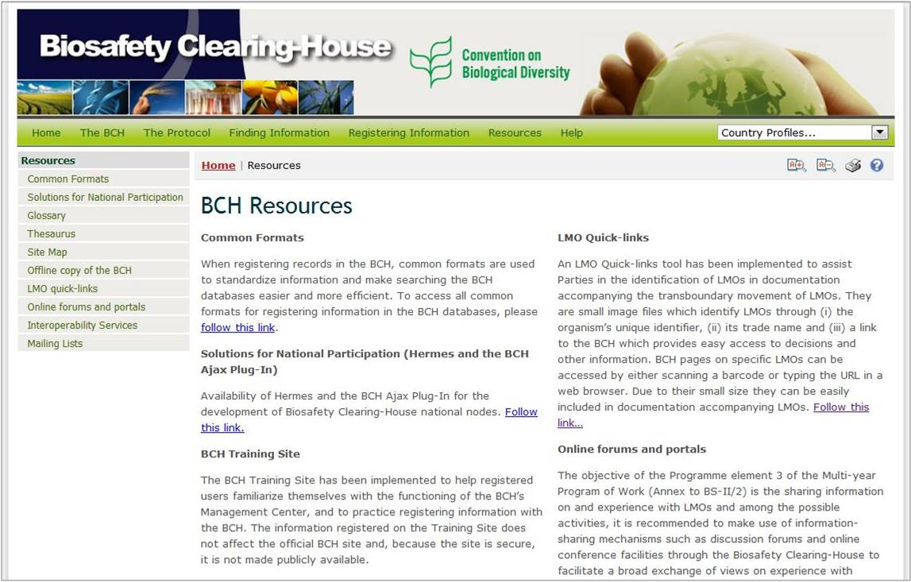

Figure

Resources

#### Common Formats

Common formats are provided to standardize the structure and organization of the information in the BCH databases. Use of these formats improves the efficiency of the BCH Central Portal and ensures easy access to information.

The common formats are the basis of the online entry forms in the Management Centre.

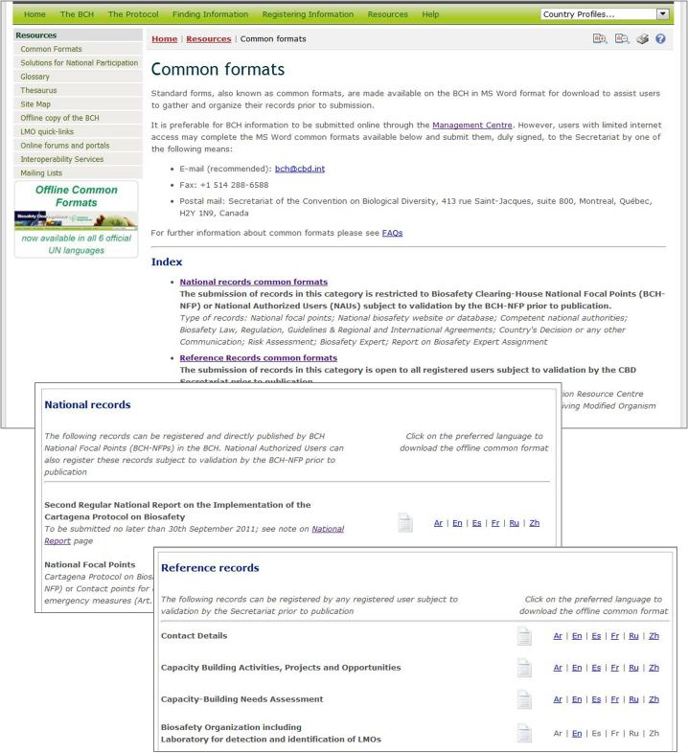

Figure

The Common formats page provides links to MS Word files of the common formats in all six official UN languages for the following categories of information:

1. **National records**

* Second Regular National Report on the Implementation of the Cartagena Protocol on Biosafety
* National Focal Points
* National Website or Database
* Competent National Authority (Article 19.2)
* Biosafety Law, Regulation, Guidelines, and Regional and International Agreements
* Country’s Decision or any other Communication
* Risk Assessment generated by a regulatory process
* Biosafety Expert (Decisions BS-I/4 and BS-IV/4)
* Report on the Assignment undertaken by the Biosafety Expert

1. **Reference records**

* Contact Details
* Capacity-Building Activities, Projects and Opportunities
* Capacity-Building Needs Assessment
* Biosafety Organization including Laboratory for detection and identification of LMOs
* Biosafety Information Resource Centre (BIRC)
* BCH News
* Risk Assessment generated by Independent or non-regulatory process
* Living Modified Organism (LMO)
* Genetic element
* Organism

#### Solutions for National Participation

The **Solutions for National Participation** links take the user to a page which provides technical information (and links to the manuals) on Hermes and the BCH Ajax Plug-In.

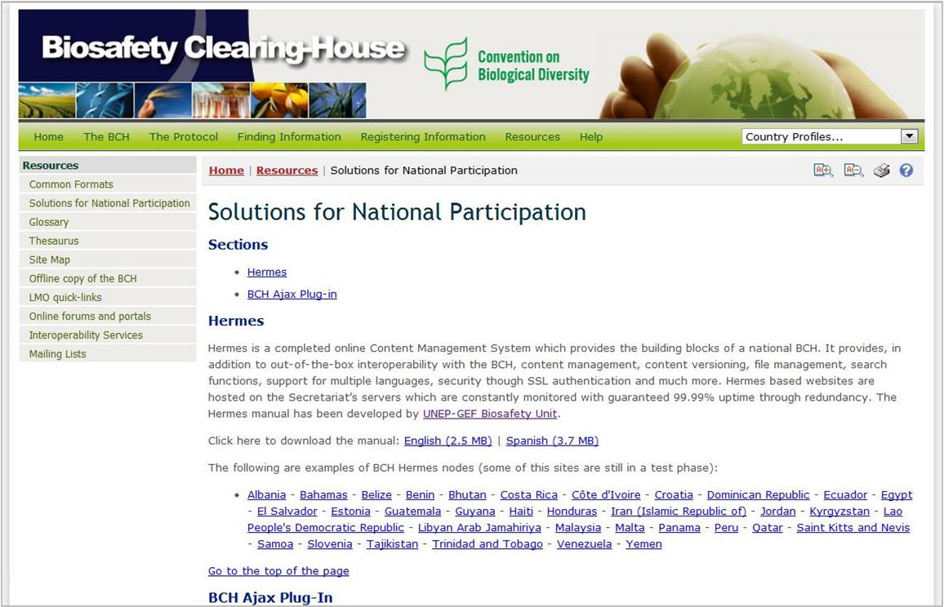

Figure

Both of these solutions are aimed toward improving the ease of accessing information in the BCH in response to identified needs of users. These solutions were created to assist countries developing their BCH national nodes to be interlinked and interoperable with the Central Portal.

#### Glossary

The **Glossary** links take the user to a page which provides a list of definitions of common terms, acronyms and expressions used throughout the BCH Central Portal.

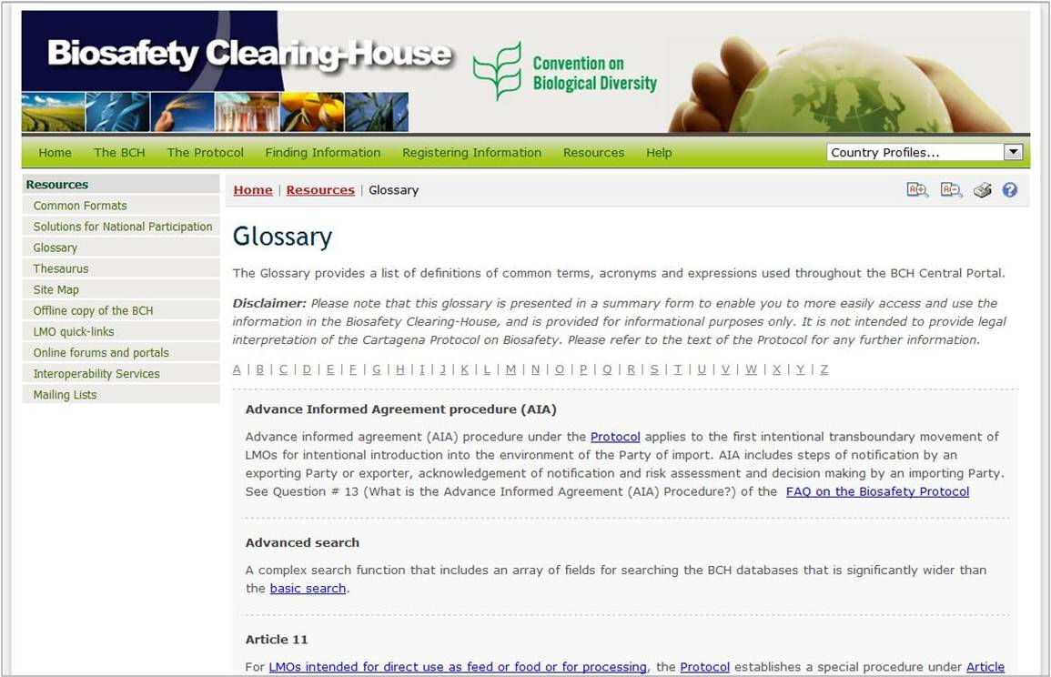

Figure

An alphabetical bar linking to sections in the Glossary is provided at the top of the Glossary page. Descriptions of all of the Glossary terms and their use are listed in alphabetical order.

#### Thesaurus

**THIS BCH SECTION IS CURRENTLY UNDER COMPLETE REVIEW BY THE SCBD**

|  |  |  |  |
| --- | --- | --- | --- |
| **littleblank.jpg**  Figure 60 | **littleblank.jpg**  Figure 61 | **littleblank.jpg**  Figure 62 | **littleblank.jpg**  Figure 63 |

#### Site Map

A detailed Site Map is provided to show how the BCH Central Portal is organized. A bar with the links to the BCH sections is placed at the top of the Site Map page. It takes the user to the corresponding section on the page. In these sections the user will find links to each page of the BCH, including the pages of the Management Centre, which are limited to registered users only.

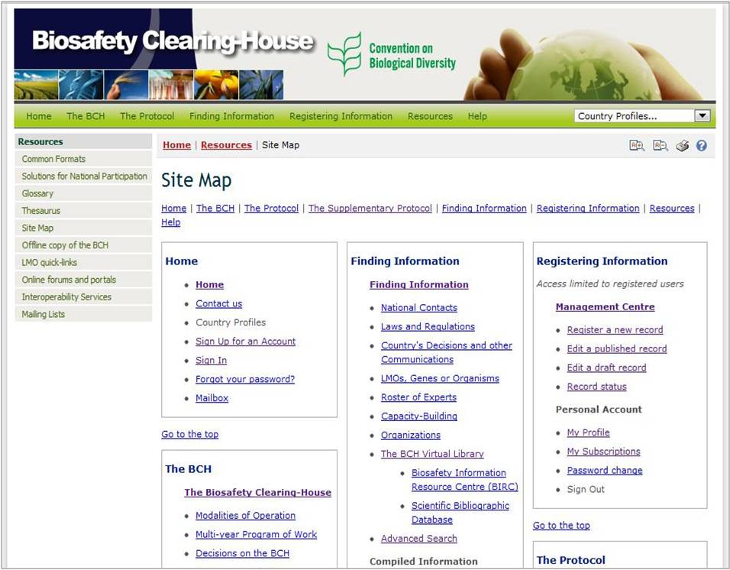

Figure

#### Offline copy of the BCH

This page provides access to the latest version of an offline copy of the BCH. The Secretariat prepares the offline copy of the BCH on a quarterly basis on DVD-ROM and ships it to the BCH National Focal Points of countries that have limited internet access. The list of countries receiving offline copies of the BCH is provided at the bottom of the page. The user can download the latest version of the DVD-ROM by following the link to the image file that can either be written to a blank DVD-ROM or virtually mounted and accessed by using a 3rd party application.

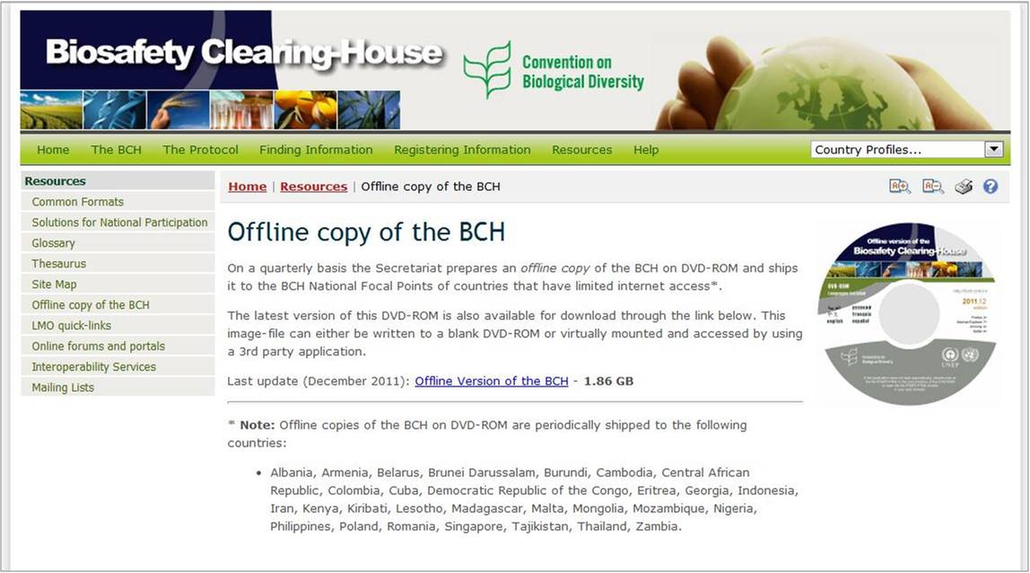

Figure

#### LMO quick-links

This section of the BCH resources provides access to the LMO quick-links. Through these links, which are small image files that identify an LMO through its unique identifier, trade name and a link to the BCH where information on the LMO is available, users can easily access the BCH page by either scanning the barcode or by typing the URL in a web browser.

From the LMO quick links page the user can download the full set of LMO quick-links in Zip and/or PDF format, as well as download a single LMO quick-link image file by using a feature **OR Select one LMO Quick-link for downloading** and selecting unique identifier from the drop-down menu. The user can also watch a short video on the LMO Quick-links, which is also available through the YouTube BCH Channel.

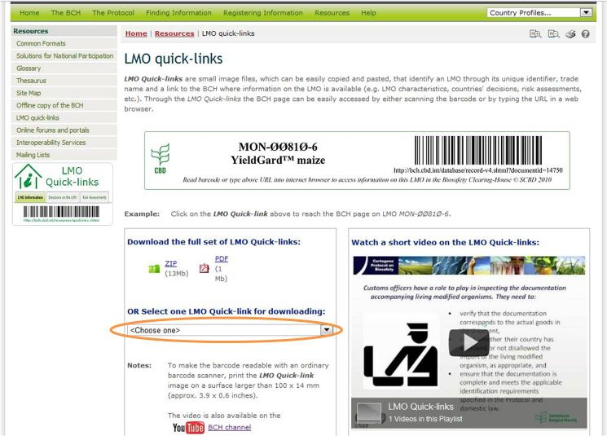

Figure

#### Online Forums and Portals

The Online Forums and Portals page provides numerous links to forums and portals that can help the BCH user to find further information. This page is organized into several sections:

* The **Ongoing Forums** section provides a list of links to currently active forums. Ongoing Forums can also be accessed through the shortcuts displayed on the right side of the page.
* Portals section provides links to several collaborative portals related to biosafety, in which the user can find further information and assistance.
* The Archived Forums section provides a list of links to closed forums.
* The Archived Surveys section provides access to a list of surveys previously conducted.

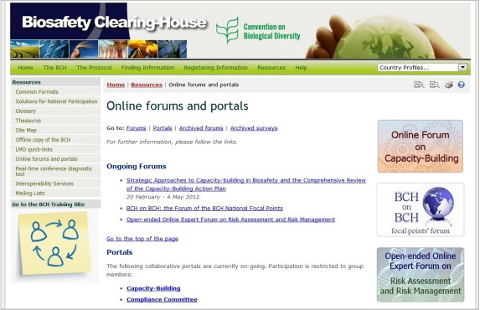

Figure

#### Interoperability Services

The BCH Interoperability Services documentation provides technical information about interoperability with the BCH including information about the BCH Web Service. It also provides XML Schemas, documentation about the Web Service Methods, and Quick Starts in VBA, C4, VB.NET, JAVA, PYTHON and PERL.

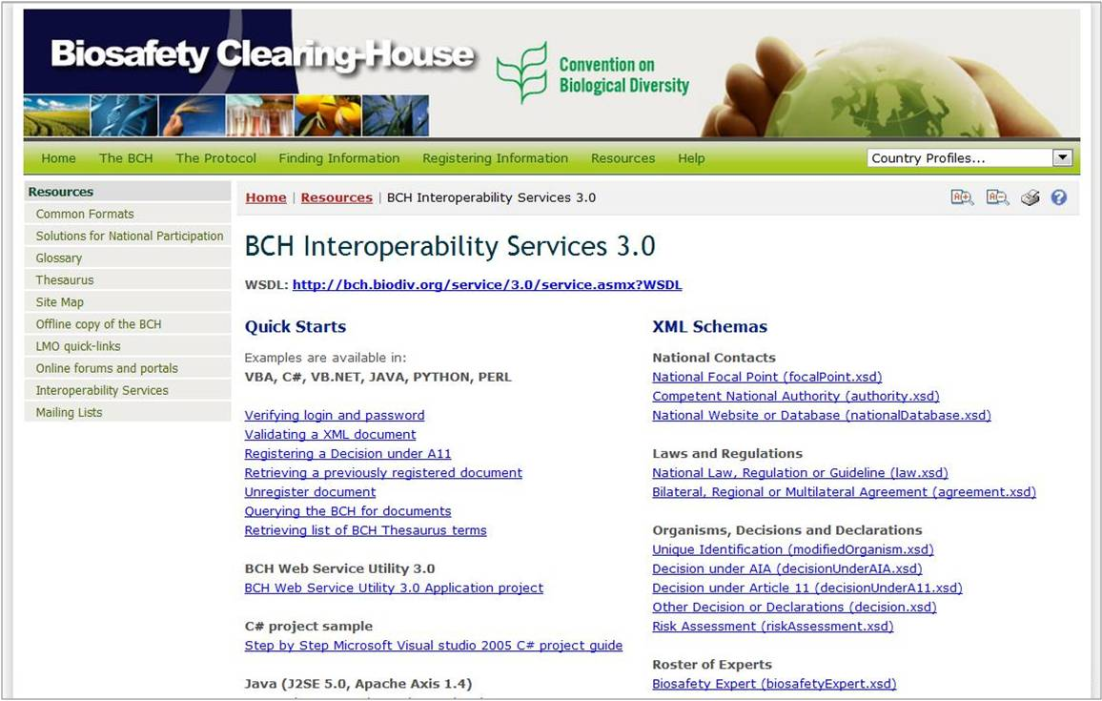

Figure

#### Mailing Lists

The Mailing Lists page provides access to the listservs that are available through the BCH Central Portal. Listservs are lists of e-mailing addresses for people who have signed up to receive regular information about a particular topic.

The BCH Current Awareness Service sends out regular updates summarizing new information that has been added to the BCH. While it is sent directly to users by e-mail, it is also possible to receive the updates by fax (please contact the Secretariat to enlist your fax number for this service).

The categories of information included in the current awareness summaries, as well as the frequency of their delivery, may be individually customized by each user.

The BCH Information Technology Specialist Updates sends out information that is intended to be of use to IT professionals who are involved in maintaining databases or websites that are interoperable with the BCH. It includes updates on changes to the BCH web service.

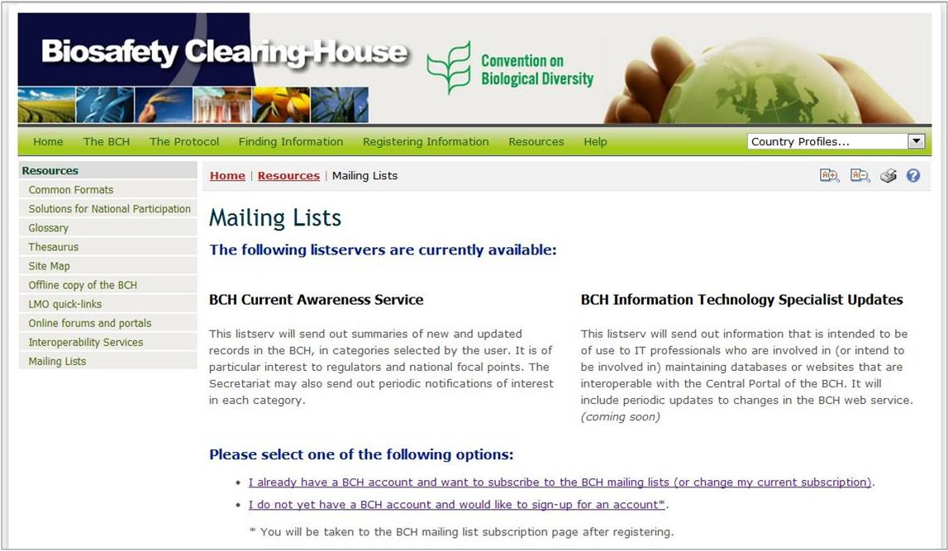

Figure

The Mailing Lists page also provides links to subscribe to the available services or to manage/update user’s subscriptions.

The first link takes the user to the Sign In to the Biosafety Clearing-House page. Once signed in, the user may subscribe to a listserv.

The second link opens the General User Account page, where users can fill in and submit their request for the BCH account.

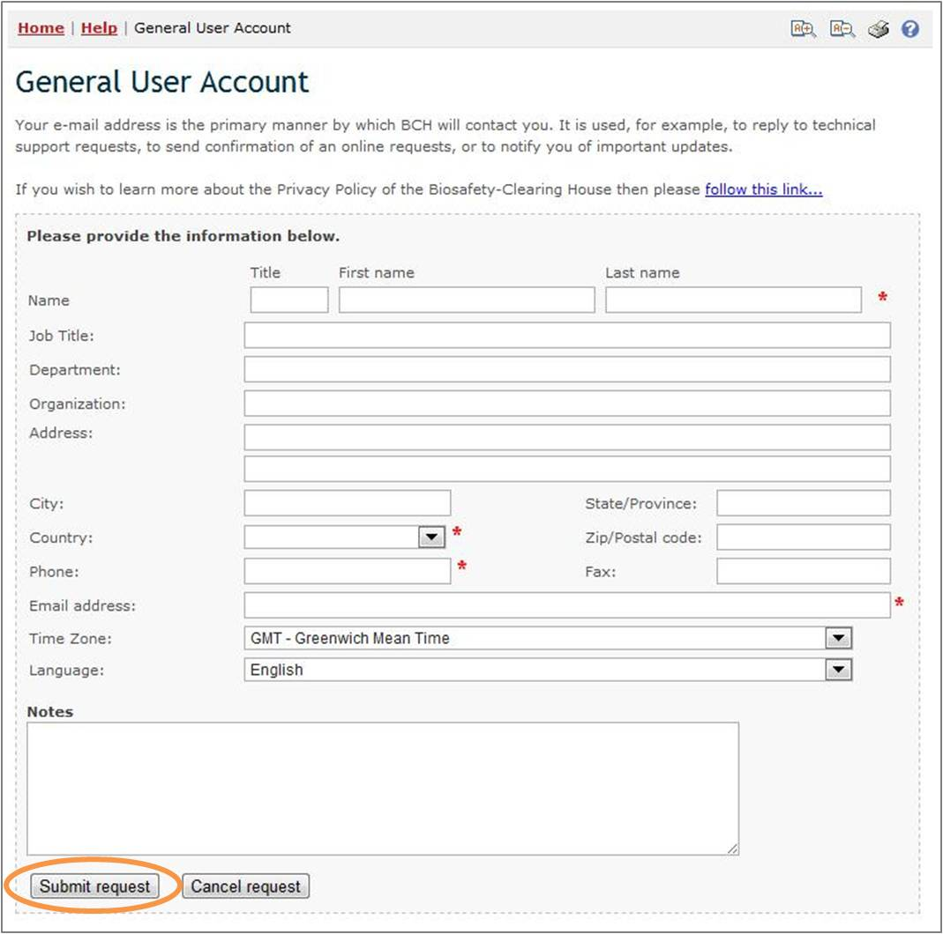

Figure

Training Site of the BCH

The Training Site of the BCH is designed to help BCH users familiarize themselves with the functioning of the Management Center without affecting the official BCH Central Portal. In order to access the Training Site, users should have a BCH account. Details on using the Training Site of the BCH are provided in Manual 06.

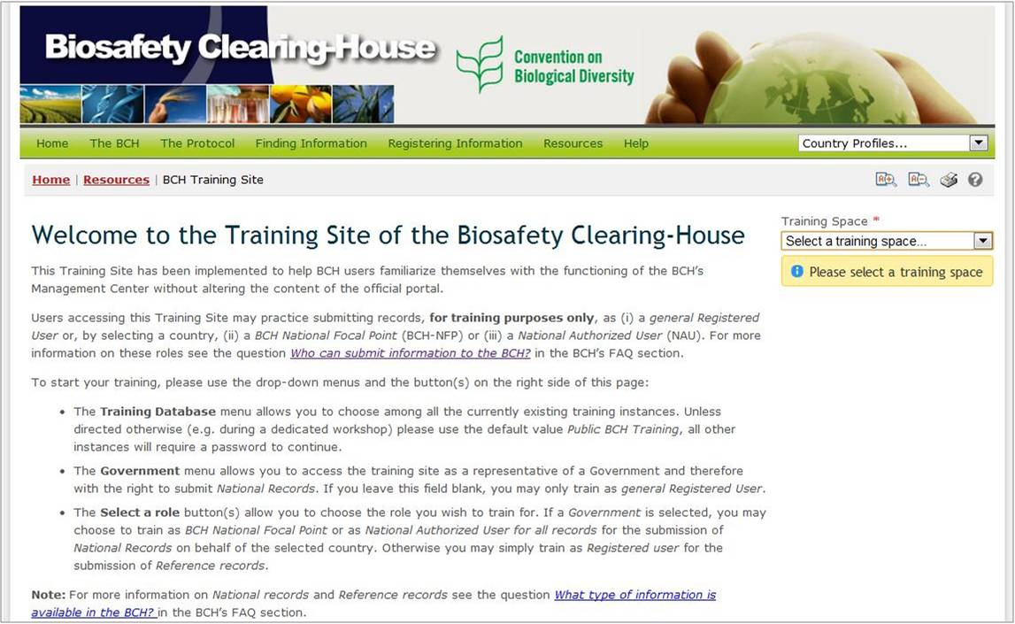

Figure

Help

URL: <http://bch.cbd.int/help/>

Clicking on the **Help** menu in the navigation bar takes the user to the Online Help System of the BCH Central Portal. This help system provides thorough information on the usage of the BCH and has been designed as a context-sensitive help system. This means that the system is able to provide help content related to the BCH pages that the user is currently using. To access context-sensitive help whenever using the BCH, simply click on the blue question mark icon  to the top right of each page.

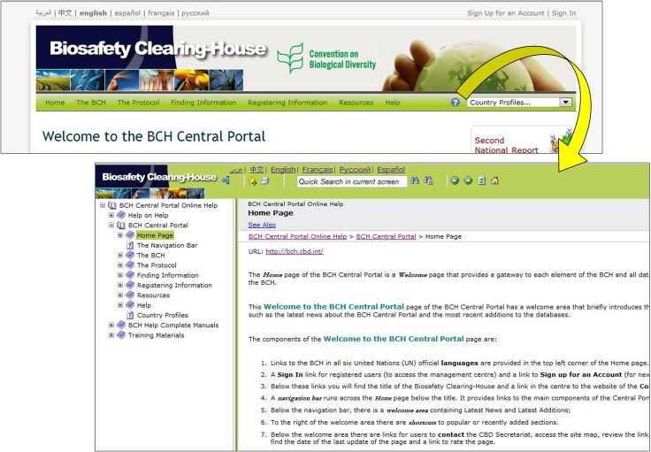

Figure

The help system has been developed in all six UN official languages, and the user can switch language as needed using the language bar of the Help System. This help system can also be used to read complete training manuals online.

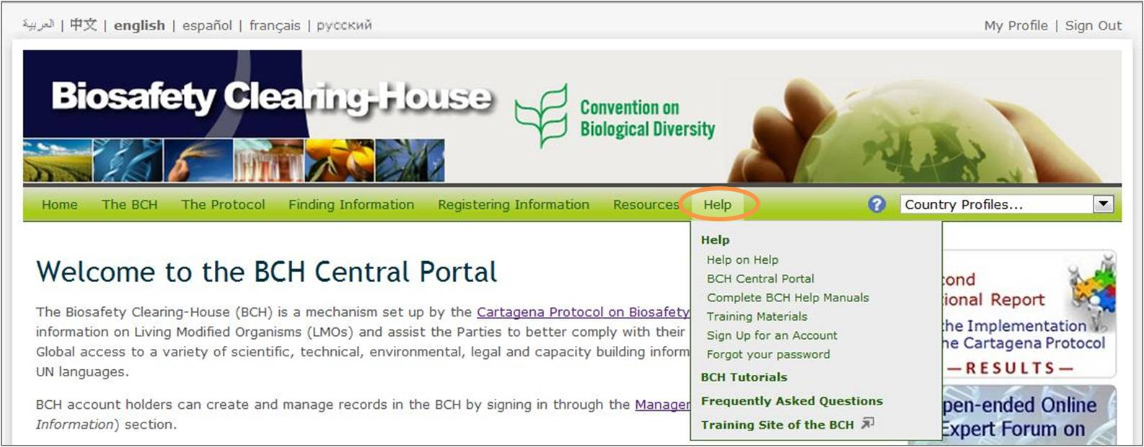

Figure

### Help

The Help menu of the BCH Central Portal provides access to several help items.

* **Help**: this is a link to help contents main page in the BCH Online Help System
  + **Help on Help**: this is a link to a help page with information about how to use the BCH Online Help System and which explains its main features.
  + **BCH Central Portal**: this link takes the user to a section in the Help System with comprehensive content about the BCH Central Portal.
  + **Complete BCH Help Manuals:** this link takes the user to a section in the Help System in which all training manuals can be found for downloading and online reading, each of them organized into several web pages.
  + **Training Materials:** this link takes to user to a section in the Help System which provides access to all training materials available for download.
  + **Sign up for an Account**: this link takes the user to the General User Account page, where the user can submit a request for the BCH account.
  + **Forgot your Password** link takes users to a page where they can retrieve forgotten password through their registered e-mail.

### BCH Tutorials

This link in the help menu takes the user to the BCH Tutorials page, in which several tutorials are available for download in various languages. These tutorials have been designed for providing guidance on the basic features of the different BCH Sections.

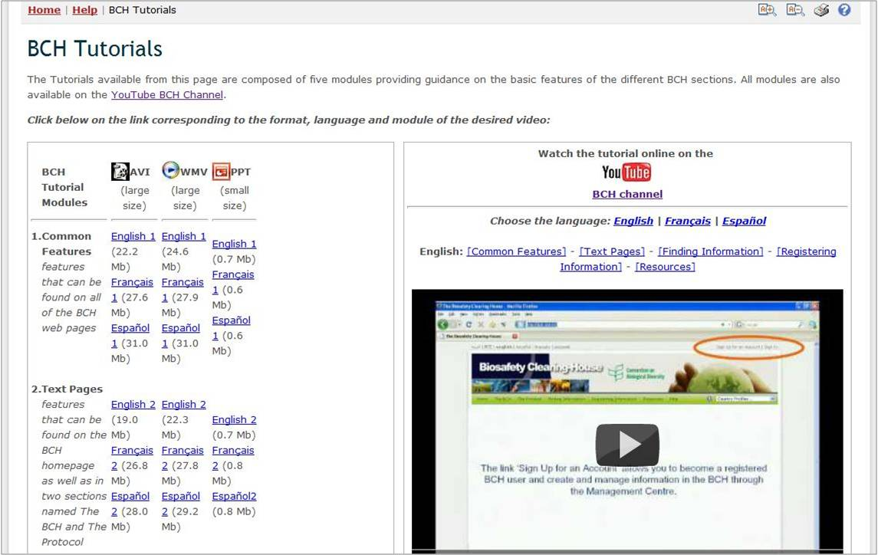

Figure

### Frequently Asked Questions

**Frequently Asked Questions** link in the help menu takes the user to the Frequently Asked Questions (FAQ) on the BCH page, which displays a collection of commonly asked questions on the BCH along with their answers. The answers provide links to articles in the Protocol and to other information available through the BCH. Users also can download a PDF file with all FAQs by clicking a link in the top right corner of the page.

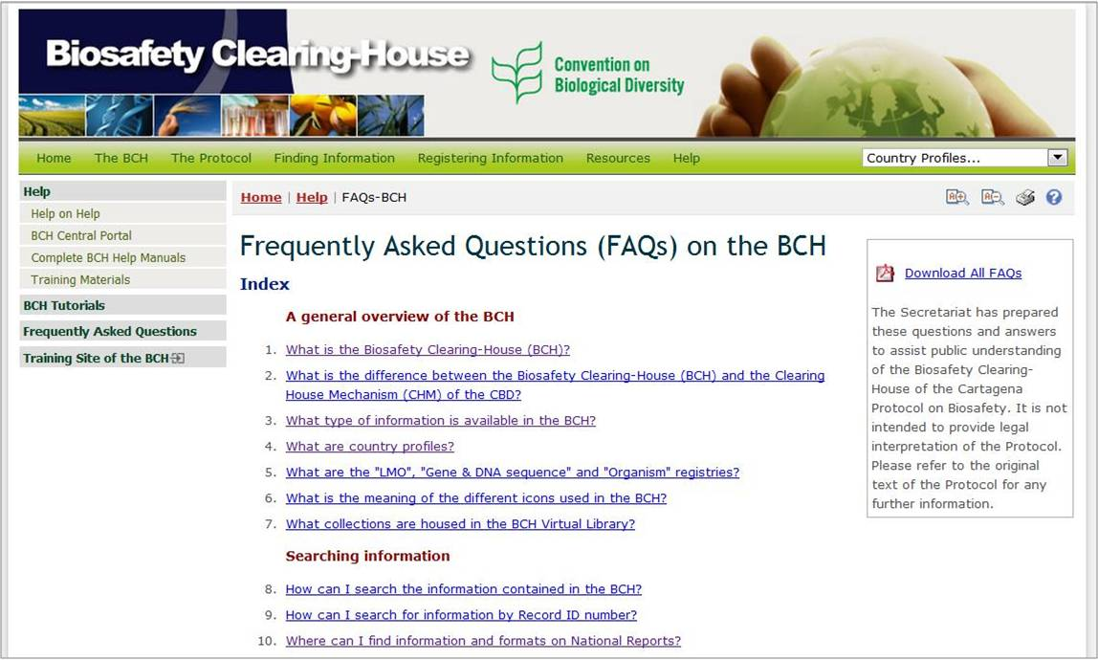

Figure